Uphall Primary School – Home Learning

Remember to add your work to TEAMS and your teacher will give you feedback.

Week beginning: 11.05.2020 (Wednesday 13th- Tuesday 19th May) Class: Primary 4G/S
Curricular Area |  | Should | Could | Even better if:
Literacy and English | 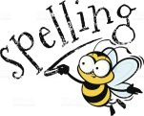 | Book of the Week: Chapter 1 of Harry Potter and the Philosophers Stone (read by Daniel Radcliffe) You can read your own copy or listen here!  https://www.wizardingworld.com/chapters/reading-the-boy-who-lived  Spelling  See spelling words attached!  Choose a task from the spelling menu and practice your spelling words using this. Aim to practise words EVERY DAY! Try writing a sentence for 5 of your words!  Grammar – Contractions  Watch…https://www.youtube.com/watch?v=5xE-vw2ctqo  How many contractions did you see? Make a list of all in your literacy jotter! For example…..  - Do not – don’t  - Will not – won’t  Show both the original version and the shortened version, this will help you with the spelling of each one! | Practise your cursive handwriting  You could write your spelling words, write your favourite bit from ch1 of Harry Potter or anything else you fancy writing!  This might help.....  https://www.youtube.com/watch?v=2NQ6uS8blwY&t=73s  Make sure you have a sharp pencil and lined paper!  Reading  You could read a chapter of your favourite book? What about a magazine? Comic? Recipe? It doesn’t matter what you read – practise makes perfect! Try reading in a funny voice or like a news reporter!  Try making up some questions for someone to answer.  Grammar part 2  Create a game/activity to help you with contractions!  See the attached sheet below for ideas! | David Walliams –Elevenses  Listen to one of these excellent books, sit somewhere cosy and share your favourite part on TEAMS.  https://www.worldofdavidwalliams.com/elevenses/  IDL – Spelling  Log in and complete one of your IDL lessons.  Writing  Summarise the first chapter of Harry Potter – Don’t remember what a summary is? Watch this…https://www.youtube.com/watch?v=dsB73dRuGcE  If you would rather you can watch today’s Newsround and summarise that! Watch here...  https://www.bbc.co.uk/newsround/news/watch_newsround
Numeracy |  | 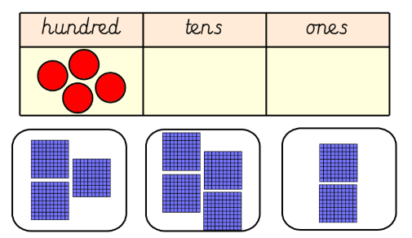  Number: Numbers to 10 000  This week we are going to revisit numbers to 10 000. We have already explored using place value using hundreds, tens and ones in school. Take some time to reflect on what you can remember about this.  Let’s get thinking…  Which image matches the number which has been made in the grid with the counters ?  See Number ‘Should activity’ on the page at the end of this file.  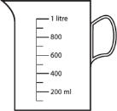  Maths: Measure  Volume  We are going to apply our knowledge of measure to solving a problem solving activity.  Use the link below to access the problem.  https://nrich.maths.org/13664  Record your thoughts in your numeracy jotter. | Number: Create your own set of number cards for the numbers 0-9. Choose 4 cards and make the biggest number you can using the digits, and then ask an adult/sibling to make the biggest number they can make. Who made the biggest number? Was there a rule to show which digits to place in which place within the number?  Maths: Measure- Volume – Finding different ways.  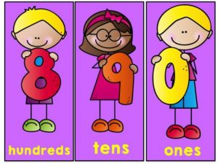  See the page below for details of this task. | Number: Log in to sum dog and complete one task every day.  Place value game  Using your own place value cards which you created make your own place value game to practice reading numbers within 10 000. This could be a game like ‘secret number’ or ‘guess my number’ which we have played in class. Share your game/ the rules on our TEAMS page.  Maths: Volume – Reading different scales  https://www.bbc.co.uk/bitesize/clips/zydpvcw  In your house use a measuring jug or your rain gauge which you made last week and practice reading the scale on the side.  How easy is it to read when the liquid does not land on a multiple of 10 or 100?  Add some photos to teams of the liquid you measure and the volume you recorded.
Health and Wellbeing |  | Physical Education: We recommend that children get at least 30 mins of physical exercise per day.  PE Session with Mr Blair:  P4G – Wednesday, break-lunch,  P4S – Thursday, 11.00-12.30pm  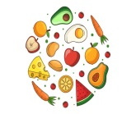  Health and wellbeing: We have already looked at the Eatwell guide in school to encourage us to bring a healthy snack. Here is the link below: https://www.nhs.uk/live-well/eat-well/the-eatwell-guide/  Use the information on the plate to create a healthy lunch/dinner menu for your family. Use a paper plate or circle of card/paper and cuttings from a magazine/newspaper to build your plate….see picture on the right. | Physical Education: Do PE with Joe Wicks daily live workouts for kids on The Body Coach TV (Youtube channel) Monday to Friday at 9am.  Health and wellbeing: Keep a food diary for the week – every day write what you ate for breakfast/lunch/dinner – on Friday – highlight all the healthy foods you ate – was it more than the un-healthy foods?  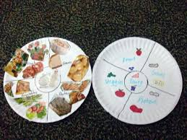  Paper plate meal (see description on the left) | Physical Education: PE challenge: Using the internet research one benefit of Physical Education for your body. Create a poster to demonstrate this benefit.  Health and wellbeing: Share some photographs of you preparing your healthy lunch/dinner?  Did you enjoy your meal?  Is there anything you would change to make it better next time?
Topic  Expressive Arts  - Art,  - Music,  Science  P4S – Wednesday 11.30-12.30pm  P4G – Wednesday  9.00-10.00am |  | Art: Weather Artwork  Create your own piece of artwork similar to the one below titled ‘Me and my Umbrella’  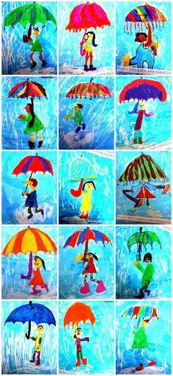  Be creative – use any art materials you have at home, even a collage would be effective! | Topic:  Choose an option from the Weather Choice menu on TEAMS.  Main topic task: Collecting data from our Rain Gauges.  - How much rain have you collected?  - Find out what ‘evaporation’ is and how this may affect your results!  - Find out about ‘the water cycle’ – how is this related to our experiment. | Music: NYCOS  View and learn the NYCOS songs daily here:  https://www.nycos.co.uk/daily-activities#today  Have a little think about:  Which materials you could use in your house to join in with the instrumental parts.  Sharing your favourite song of the week on a Friday.  Asking an adult/ sibling to join in with one of the songs!

Contractions – Ideas

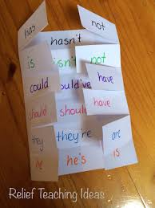
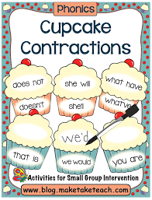
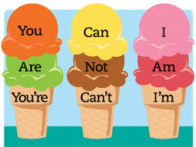

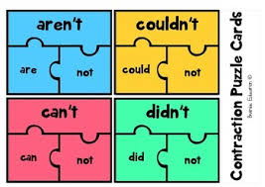
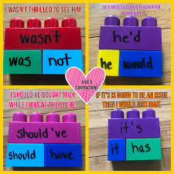

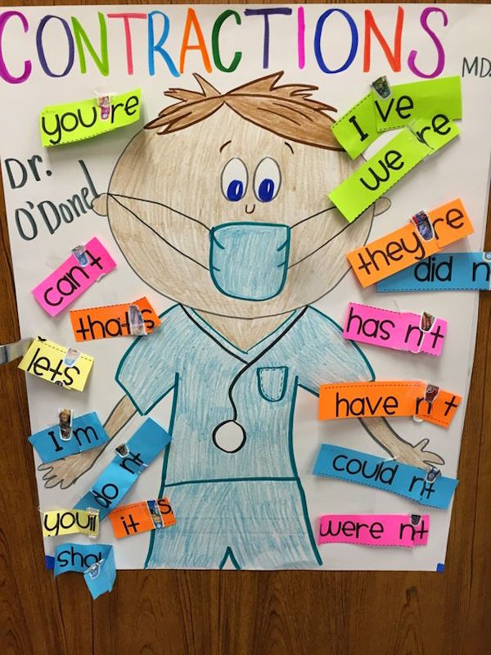

Spelling Words – P4S

Grapes | Raspberries | Blueberries
ea  beach  each  peach  reach  teach  lead  read  speak  weak  deal | dis  disable  disagree  disarm  disclose  discover  disease  disgrace  dislike  disown  disobey | ys  birthdays  boys  chimneys  cowboys  donkeys  jerseys  jockeys  journeys  monkeys  abbeys

Spelling Words – P4G

Sapphires (ild,ind,int) | Rubies (al) | Diamonds (ai)
mild  wild  behind  blind  find  kind  mind  wind  pint | almighty  almost  alone  along  already  alright  also  altogether  always | affair  afraid  against  bargain  Britain  certain  complain  curtain  despair  entertain  fountain  maintain  mountain

Measure: Finding different ways
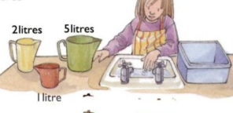

Elsie has 3 different measuring jugs. The yellow one holds 2 litres, the green one holds 5 litres and the red one holds 1 litre.

She wants to measure 3 litres into the basin beside the sink.

Find three different ways that she could measure 3 litres into the basin using the measuring jugs she has.

Record your answers in your numeracy jotter.

Number - ‘should activity’
We are going to focus on ordering and identifying numbers within 10000.

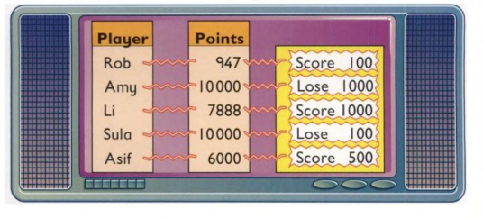
For each of the numbers in the green
box add on 100 more. Write the new number
that you have made.
Add 100
3840

1900

6305

4913

Game Time
The screen above shows the amount of points each player scored in round 1 of a TV game. (in the orange ‘points’ box.
The yellow box then tells you whether they lost points or scored additional points in round 2.
Write down how many points each player has now.

7268

9002

7829

8000

For each of the numbers in the blue
box take away 100. Write the new number
that you have made.
Subtract 100

