Maths Challenge

Remind yourself of the names of these 3D shapes.

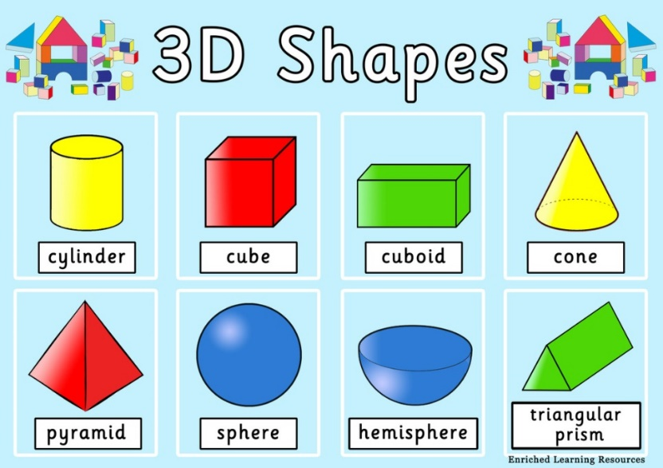

Can you identify any of these shapes around your house?

L.I. To identify and make 3D shapes.

Go on a 3D shape hunt around your house and record what you find (in a table like this)!?

|  |  |
| --- | --- |
| Name of 3D shape | Example from my house (draw) |
| Cylinder | C:\Users\jennifer.hall\AppData\Local\Microsoft\Windows\INetCache\IE\HXGRCML5\Soda[1].jpg |

Can you identify the 3D shapes in this Art work?

