Maths Challenge

Lots of Art Work uses symmetry. Something is symmetrical when it is the same on both sides. Remember symmetry means a mirror reflection.

1. LI- To find lines of symmetry

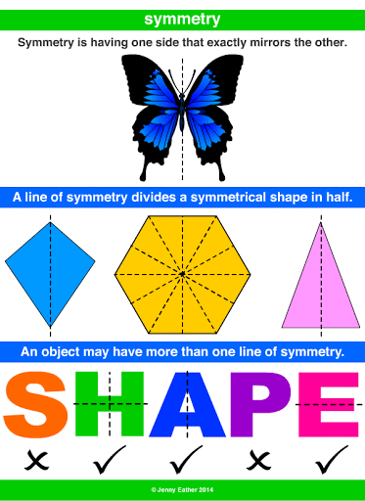

Task 1

Can you spot the symmetry in this art pieces? How many lines of symmetry can you see?

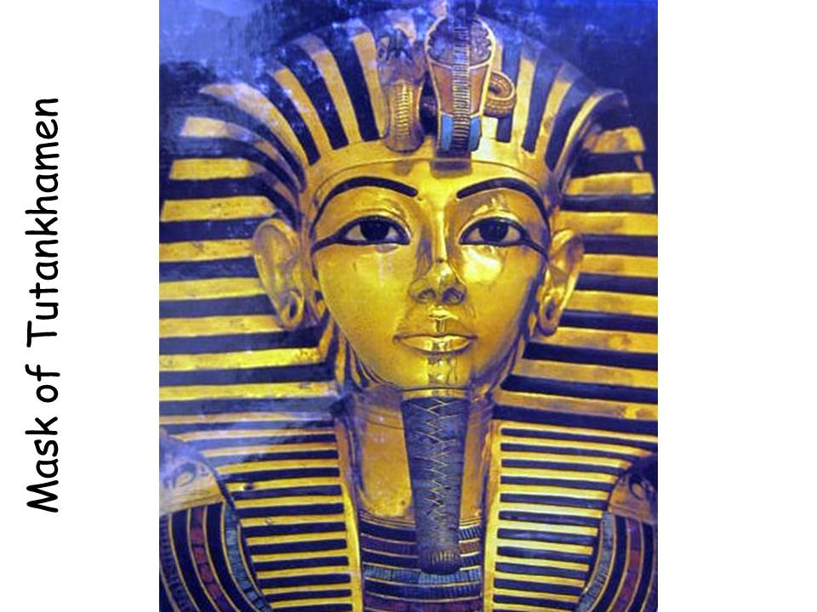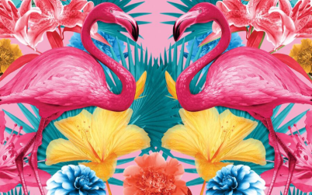

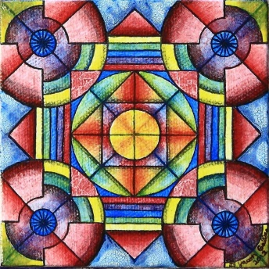

Task 2

Can you create a piece of art using a line of symmetry? Remember both sides need to be the same. You can look around your house or outside for ideas.

