Monday 11th May 2020
Daily Activities

Celebrity classes – on files

Below you will find each curricular area Numeracy/Literacy/Across the curriculum. You can choose no more than two of the activities in each section to complete.

Numeracy

- Mild/Hot chilli challenge – on files/attached to email/on blog
- BBC Bitesize – multiplying and dividing problem solving https://www.bbc.co.uk/bitesize/tags/z63tt39/year-4-lessons/1
- Splat – 4.3 – on files/attached to email/on blog
- Investigate Capacity - get a collection of containers, such as cups, saucepans, egg cups and bowls. Estimate how many smaller containers it takes to fill a larger one, e.g. how many egg cups of water it takes to fill a saucepan. Try it out and see if your estimate was close. Use the water on household plants or in the garden so it doesn’t go to waste.
Literacy

- BBC Bitesize – Exploring recounts
https://www.bbc.co.uk/bitesize/tags/z63tt39/year-4-lessons/1
- Using your spelling words create a word search for a family member to complete.
Positive Pineapples | Wonderful Watermelons | Keen Kiwifruits
ear  hear  year  read  beard  head  bread  spear | dead  head  read  bread  thread  spread  health  ready | wealthy  healthy  steady  ready  weather  leather  feather  wealth

- Write 3 sentences using the word of the day
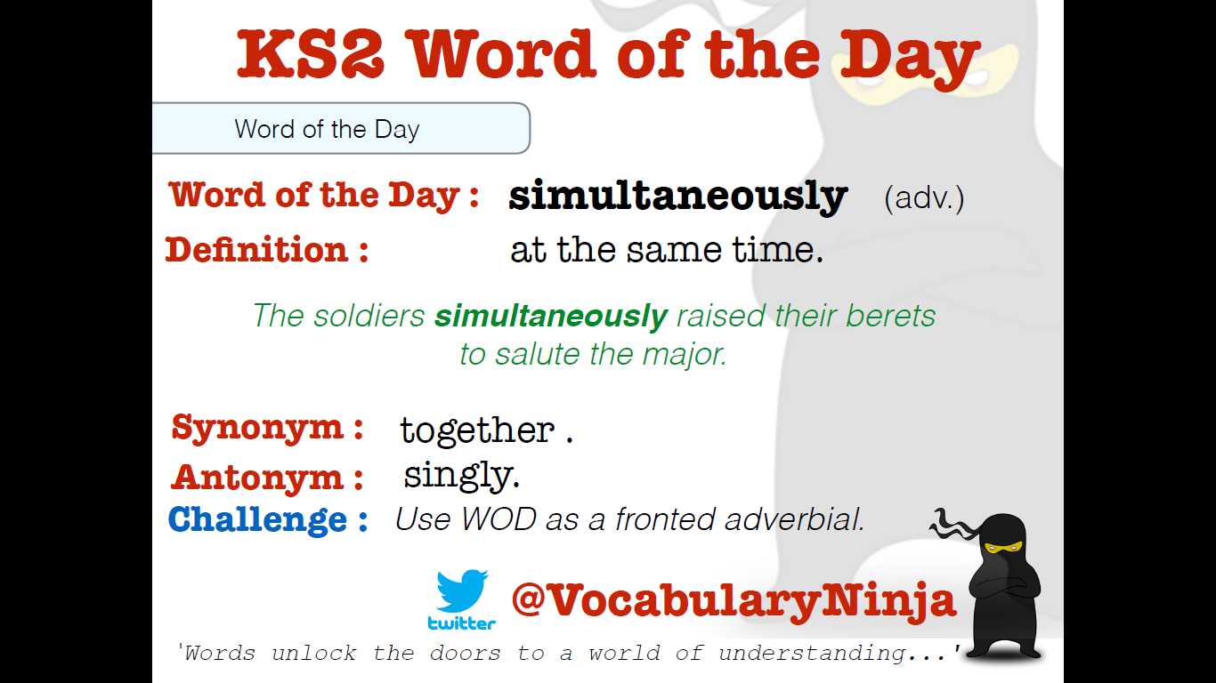
- Choose a book you know very well and rewrite it from another point of view for example
Write ‘Cinderella’ from the point of view of one of the ugly sisters or write Goldilocks and The Three Bears from the point of view of Goldilocks.
Across the Curriculum

Choose 1 activity below to complete this afternoon. (This is also uploaded onto files)

