People Who Help Us
We would like you to learn more about People Who Help Us over the course of this week by creating your own project. You can choose to find out about a paramedic, doctor, nurse, dentist, firefighter, police officer, lollipop person, teacher, refuse collector, postal worker or bus driver.
You can present your project in any way you like-in your home learning jotter, making an informative poster or perhaps you would like to make a lapbook (some pictures on next page as examples).
Success Criteria: I can
- share my knowledge about someone who helps us
- include details about the job they do (uniform, equipment/tools used, how they learn to do their job-e.g. do they have to go to college or university, say where they work)
- say why their job is important
- add pictures/photos (you could label these using words to describe them)

https://www.youtube.com/watch?v=fZimXR8aW8U (Whose Hands Are These story)
https://www.youtube.com/watch?v=V1SStl6r00M (Whose Hat Is This story)
https://www.youtube.com/watch?v=1bDwCPcQT0s (Whose Tools Are These story)
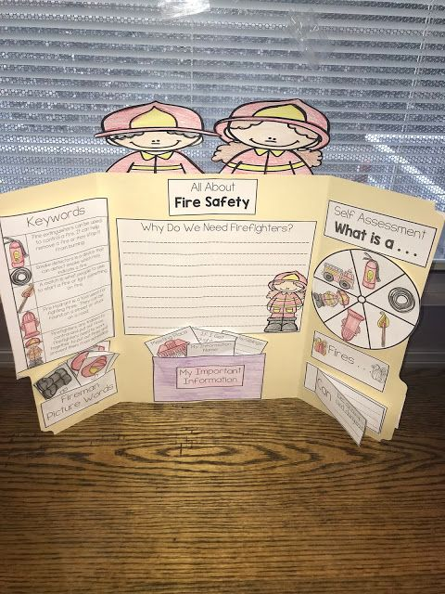

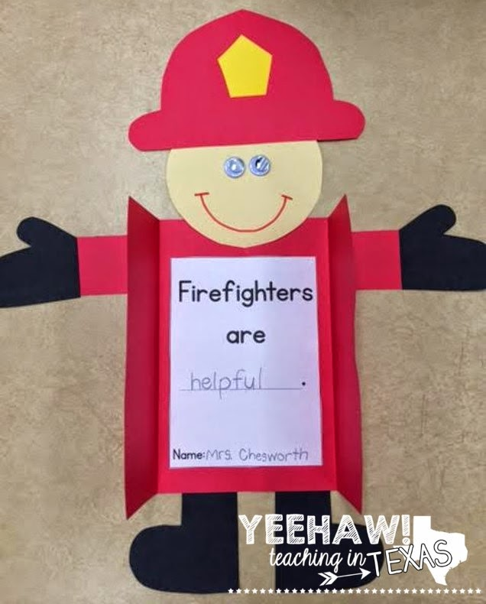

Labelled picture example

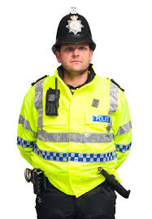

helmet

high visibility jacket radio mic/
walkie talkie
baton

Additional tasks-just for fun
- Make a model of something related to the job your person does (e.g. hospital from lego or old boxes, fire engine out of recycled materials)
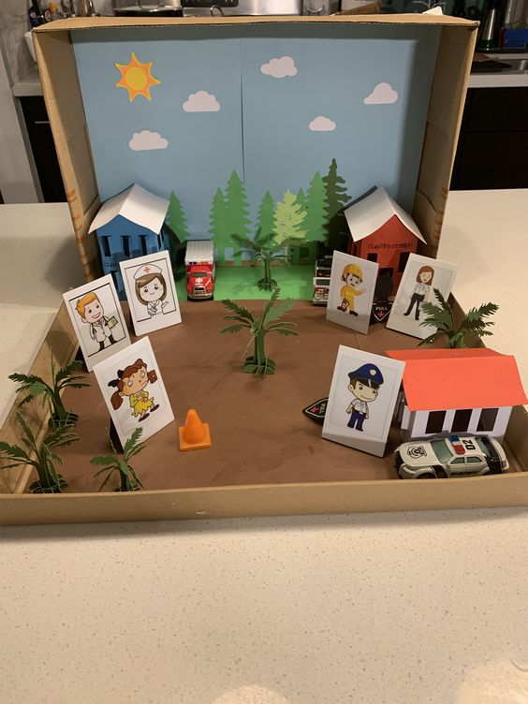
- Dress up as your chosen person for a day (maybe your family could create some simple scenarios for you to act out (e.g. if you are a nurse perhaps someone in your family isn’t feeling well and you have to help them feel better)
- Create a people who help us diorama
(a scene made inside a shoe box)
- Watch cartoons about people who help us
e.g. Fireman Sam, Postman Pat
Peppa Pig goes to the dentist
https://www.youtube.com/watch?v=r-jrs5KQ3aA
Hilltop Hospital https://www.youtube.com/watch?v=KQ06CUDAkJs

- Create a washing line of clothes for the job you are finding out about after watching this
https://www.youtube.com/watch?v=lJlYULkuDvo

