Wednesday 6th May 2020
Daily Activities

Celebrity classes – on files

Numeracy
- Choose a problem of the day below
Mild
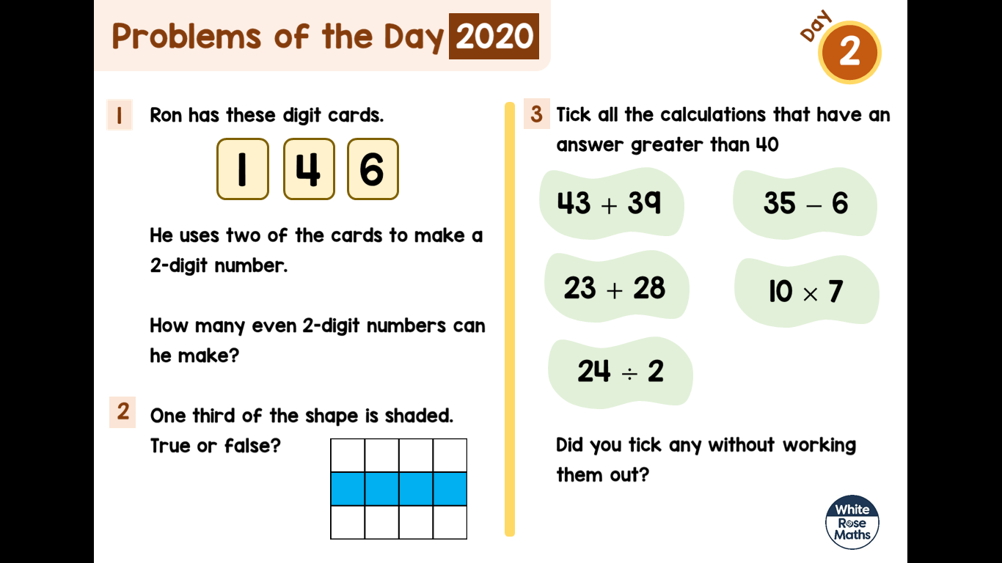
Hot
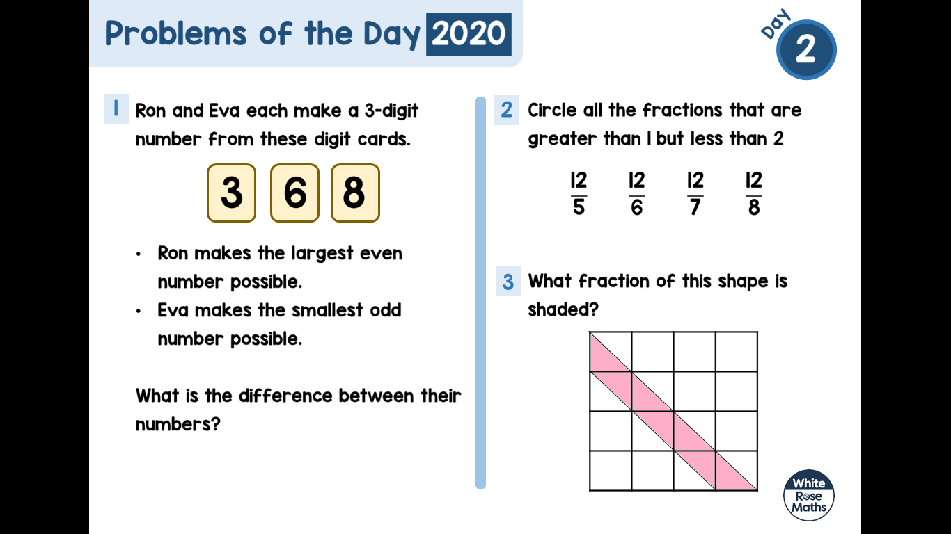
Literacy

The Visitor
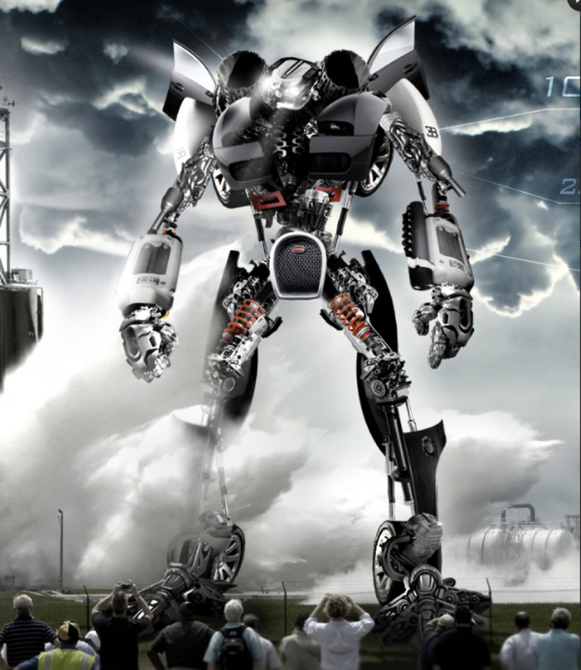
Question Time – (you can keep your answer in your head or write it down)
- Who do you think is controlling the robot?
- Where has the robot come from?
- Are the people in danger?
Sentence Challenge
A preposition is a word that shows the relationship between one thing and another. It may tell you where a thing is in relation to something else, e.g.

The silver, shining giant stood on the car.

It may tell you when something is in relation to another event, e.g.

The crowd watched until the giant departed.

Can you write 3 sentences that contain prepositions?
Is it possible to begin a sentence with a preposition? What about trying to start and end a sentence with a preposition?

Uplevel the sentences
The robot stood in front of the people.
His hands and feet were big, and his body was really big.

Perfect Picture
Imagine your job is to design a robot. Draw or describe what your robot would look like, and what it could do.

Across the Curriculum

Choose 1 activity below to complete this afternoon. (This is also uploaded onto files)

