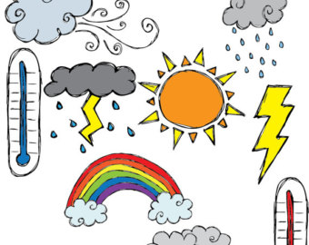
Weather Recordings Activity
This week we are going to design a:
Rain Gauge
Please use the link below and the example provided to create your own rain gauge.
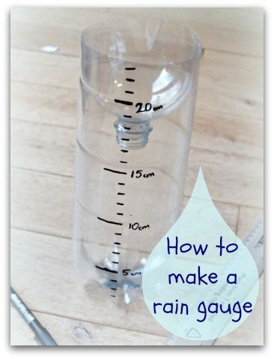
https://theimaginationtree.com/homemade-rain-gauge/

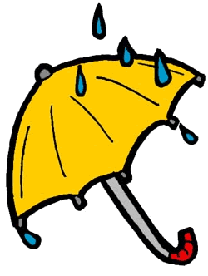
You should also create:
- a recording sheet to record your measurements on daily,
- a safe place in your garden for your rain gauge to stand,

