Uphall Primary School – Home Learning

Remember to add your work to TEAMS and your teacher will give you feedback.

Week beginning: 04.05.2020 Class: Primary 4G/S
Curricular Area |  | Should | Could | Even better if:
Literacy and English | 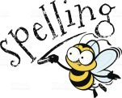 | Book of the Week: Charlie & the Chocolate Factory – Chapter 1. Read this if you have the novel at home OR listen here: https://www.youtube.com/watch?v=coGg0LMFKSE  (Watch until 6:10)  Spelling  See spelling words attached!  Choose a task from the spelling menu and practice your spelling words using this.  Grammar  Compound words – 2 words which when put together make a brand new word! For example –  Sun + flower = sunflower  https://www.youtube.com/watch?v=2U0OBDRvkKo  Find as many compound words as you can – record them in your jotter. | Practise your cursive handwriting  You could write your spelling words, write your favourite bit from ch1 of Charlie and the Chocolate Factory or anything else you fancy writing!  This might help.....  https://www.youtube.com/watch?v=2NQ6uS8blwY&t=73s  Make sure you have a sharp pencil and lined paper!  Reading  You could read a chapter of your favourite book? What about a magazine? comic? recipe? It doesn’t matter what you read – practise makes perfect! Try reading in a funny voice or like a news reporter!  Try making up some questions for someone to answer. | David Walliams –Elevenses  Listen to one of these excellent books, sit somewhere cosy and share your favourite part on TEAMS.  https://www.worldofdavidwalliams.com/elevenses/  IDL – Spelling  Log in and complete one of your IDL lessons.  Hot Seating  Choose one of the texts you have read over the last few weeks. From this identify one character and have a shot of ‘hot seating’ as this character. This means that someone – an adult/sibling has a shot at asking you questions about the character that you have chosen and you answer them, in role as the character. They might ask “how did you feel when you won the Golden ticket?”
Numeracy |  | Number: Watch these fun clips to recall the stations of the 8 & 9 times table.  https://www.bbc.co.uk/teach/supermovers/ks2-maths-the-8-times-table-with-filbert-fox/z4mrhbk  https://www.bbc.co.uk/teach/supermovers/ks2-maths-the-9-times-table/zr2gt39  Use the Cuisenaire rods that we looked at last week to investigate the 8 & 9 times table.  See sheets attached below.  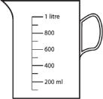  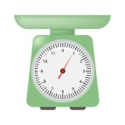  Maths: Measure  Volume & Weight Scavenger Hunt  We are going to focus on two pieces of measuring equipment for this activity. One which measures volume and one which measures weight.  A measuring jug – volume  A scale – weight  Search around your house and find 5 items which you would use a measuring jug to find the volume of and 5 items which you would use the scales to find the weight of! | Number: Create your own game for the 8 & 9 times table which gets people moving! This could be a treasure hunt or a sporty game. Share it on our TEAMS page.  Maths: Volume experiment.  Equipment:  5ml spoon,  Cup (that you might have juice in)  Water (in a separate container)  Using the 5ml spoon start to spoon the water from the container into the cup.  How many spoonful’s did it take to fill the cup with water?  How could you work out how much water is now in the cup?  Share your results on our TEAMS page. | Number: Log in to sum dog and complete one task every day.  Watch these episodes of MEGAMATHS to help you with your times tables: 8 times table:  https://youtu.be/Ua-S4YZVfbs  9 times table:  https://youtu.be/I5rSrkK3OXA  Maths: Weight – Create your own!  Part of volume and weight is practicing the skill of estimation.  Here is an example of an activity where you should identify which item is heavier:  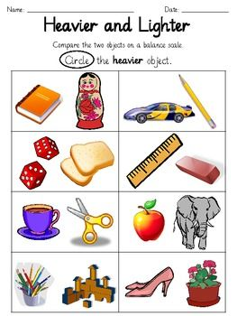  Now using objects in your house create 3 examples of your own. Think about making these challenging and post one of your examples on our TEAMS page for another pupil to guess.
Health and Wellbeing |  | Physical Education: We recommend that children get at least 30 mins of physical exercise per day.  PE Session with Mr Blair:  P4G – Wednesday, break-lunch,  P4S – Thursday, 11.00-12.30pm  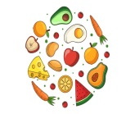  Health and wellbeing: We have already looked at the Eatwell guide in school to encourage us to bring a healthy snack. Here is the link below: https://www.nhs.uk/live-well/eat-well/the-eatwell-guide/  Use the information on the plate to create a healthy lunch/dinner menu for your family. | Physical Education: Do PE with Joe Wicks daily live workouts for kids on The Body Coach TV (Youtube channel) Monday to Friday at 9am.  Health and wellbeing: Ask an adult at home to help you to prepare your healthy lunch or dinner for your family. What did they think of your healthy lunch/dinner? | Physical Education: PE challenge: Using the internet research one benefit of Physical Education for your body. Create a poster to demonstrate this benefit.  Health and wellbeing: Share some photographs of you preparing your healthy lunch/dinner?  Did you enjoy your meal?  Is there anything you would change to make it better next time?
Topic  Expressive Arts  - Art,  - Music,  Science  P4S – Wednesday 11.30-12.30pm  P4G – Wednesday  9.00-10.00am |  | Art: Weather Artwork  Look at the pictures attached of Van Gogh and his painting collection – The Seasons. Think about these questions as you look at this work.  Questions:  1. What materials has he used to create his artwork?  2. What different weather types are shown within these paintings?  3. What interesting techniques e.g. brush strokes has he used to show the weather in each painting? | Topic:  Choose an option from the Weather Choice menu on TEAMS.  Main topic task  Weather measuring task  see separate file on TEAMS | Music: NYCOS  View and learn the NYCOS songs daily here:  https://www.nycos.co.uk/daily-activities#today  Have a little think about:  Which materials you could use in your house to join in with the instrumental parts.  Sharing your favourite song of the week on a Friday.  Asking an adult/ sibling to join in with one of the songs!
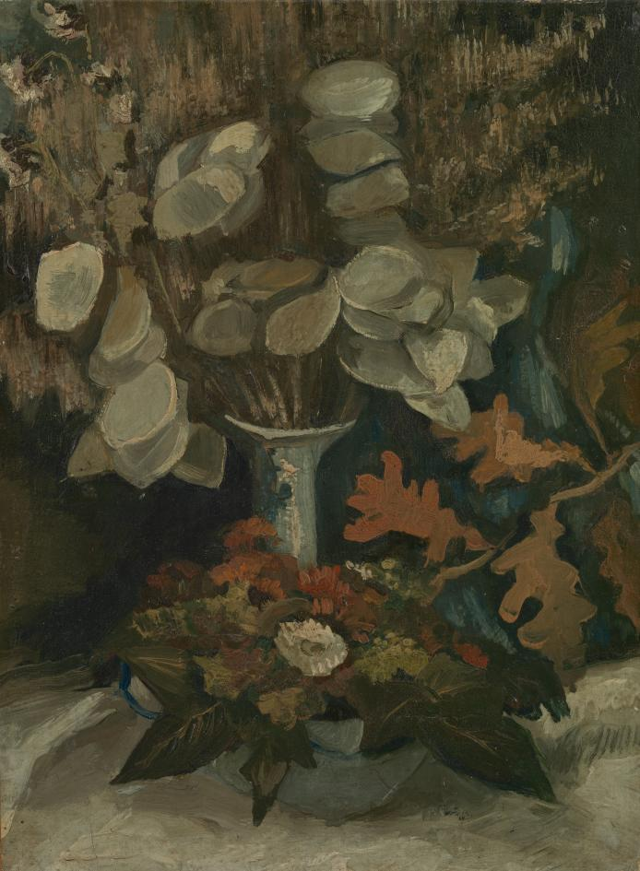
Art – Vincent Van Gogh
The Seasons

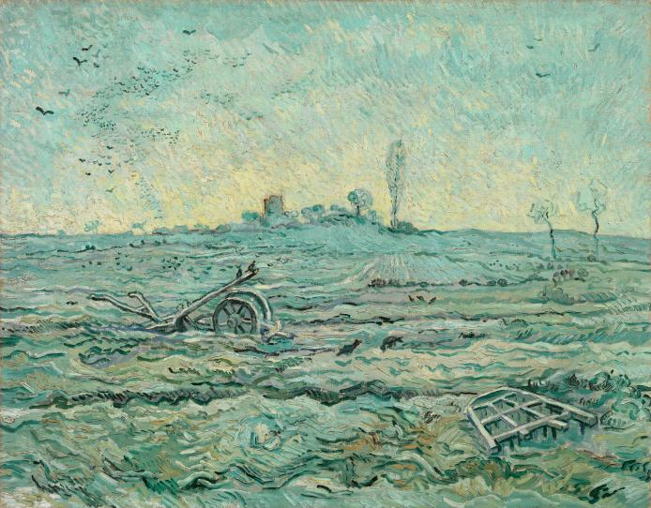

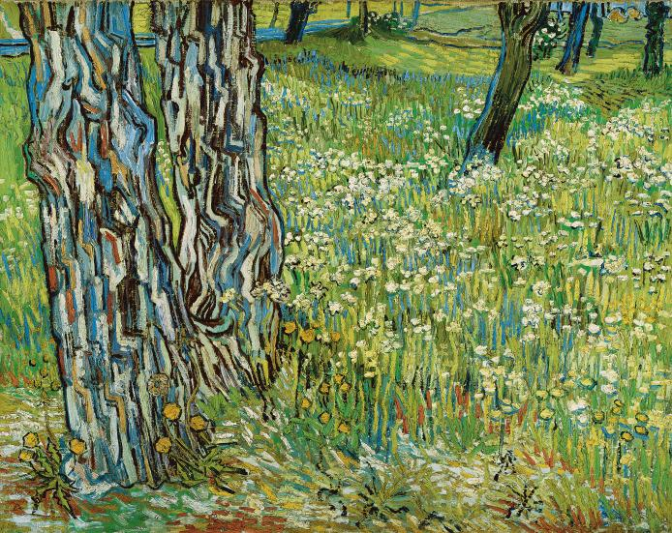

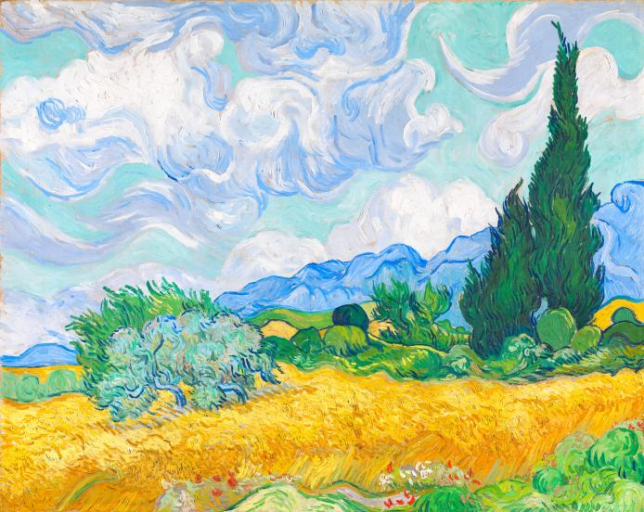

Numeracy – Cuisenaire Rods
8 times table

We have used the rods in class to explore other tables so let’s do some investigation…
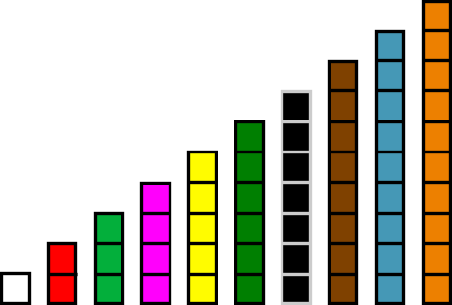

If the white rod is worth 8, find out how much is the:
Red rod
Green rod
Pink rod
Yellow rod
Dark green rod
Black rod
Brown rod
Blue rod
Orange rod
Now thinking about the white rod again.
If the white rod is worth = 8

How many white rods would make a green rod for example?

Looking at this example again!

Is there another way that we could write about how many white rods are equal to the green one?
We could write:
3 x 8 (because each white rod is worth 8) = 24
3 of the white rods fits on top of the green rod giving a total of 24
Choose 2 of your answers to the practice task above and now see if you can use multiplication to show how many white rods is equal to your chosen colour.

Can you draw this using the rods for example;

3 white rods
=

Now complete these statements and draw the rods to show which
rods and equivalent to others like the example above.
Practice Activity
How many white rods would make;
- a yellow rod
- a pink rod
- a dark green rod
- an orange rod
- a blue rod
- a black rod
- a red rod
- a brown rod
Repeat this activity for the 9 times table, this time the white rod is worth 9.

Spelling Words – P4S

Grapes | Raspberries | Blueberries
air  chair  fair  hair  lair  pair  stair | refill  reform  refresh  refuse  repay  replace | buffaloes  cargoes  dominoes  echoes  Eskimoes  heroes  potatoes  tomatoes

Spelling Words – P4G
Sapphires (old) | Rubies (compound words) | Diamonds (ear)
bold  cold  fold  gold  golden  hold  old  sold  told | bedroom  blackbird  bonfire  cloakroom  clockwise  cupboard  database  football  goalkeeper  goodnight  grandfather  handbag  household | early  earn  earth  earthquake  earthworm  heard  learn  pearl  rehearse  research  search  unheard  yearn

