How to make a strawberry smoothie

Today, I would like you to check these instructions for a STRAWBERRY SMOOTHIE make sense because I think they’re in the wrong order.  I’d like to make one over the weekend but I need you to unscramble these instructions.

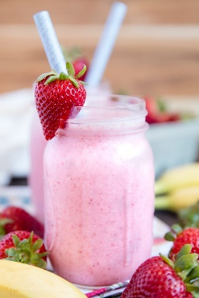

You could tell someone the answers, write down the answers or copy the sentences in the correct order. You could write in your jotter, on paper, in the comments here (or on Twitter).  If you have a printer, you could print the instructions out then cut and paste in the correct order.

If you have any fruit left at home (after making fruit kebabs and funny faces), why not try making a fruit smoothie over the weekend. If you don’t have fruit you could make your own creation and share it.  I’m sure ice-cream could be used since it’s the weekend!  You might need help from a trusted adult.