Today’s Maths challenge!
If the weather clears up and you go on your daily walk can you count the number of rainbows you see? (If it stays very wet today, perhaps use tally marks to count something around your house or garden, such as objects with each colour of the rainbow?)
Can you use tally marks to represent the quantity and total them up at the end?
Can you skip count in 5s to help you calculate the total?
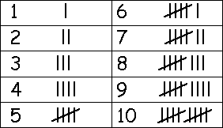
Don’t forget to use a diagonal line when you reach a multiple of 5!
LI. I can use tally marks to represent the quantity and total them at the end
SC. I can use tally marks to represent the number of rainbows
I count the total of tally marks at the end
I can skip count in 5s

