P2 Thursday 30th April 2020 – Literacy - Functional writing (instructions part 2 of 3)
I hope you all enjoyed making fruit kebabs yesterday. Today, I would like you to write your own instructions for the fruit kebab you made (or whatever creation you made). You could draw each step, write down each step or draw and write each step. You could even tell someone else how to make your fruit kebab.

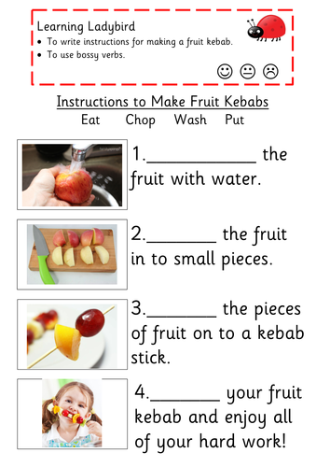 *I

How can you make your instructions different to the ones we used yesterday? Perhaps you used different fruits and in a different order. Perhaps you can think of different bossy words? If possible, please comment on the blog to let me know how you get on, tweet pictures of your work to Twitter or e-mail pictures to the school e-mail address.

