Wednesday 29th April 2020
Daily Activities

Here are some ‘celebrity classes’ which you can engage with each day.

9:00 | PE with Joe Wicks | Youtube.com/thebodycoach
10:00 | Music with Myleene Klass | Youtube.com/myleenemusicklass
11:00 | Science with Maddie Moate | Youtube.com/maddiemoate
11:30 | Dance with Oti Mabuse | Youtube.com/otimabuseofficial
13:00 | Maths with Carol Vorderman | Themathsfactor.com
14:00 | History with Dan Snow | Tv.historyhit.com
15:00 | English with David Walliams | Worldofdavidwalliams.com
17:30 | Food Tech with Jamie Oliver | Channel4.com/keepcookingandcarryon

Below you will find each curricular area Numeracy/Literacy/Across the curriculum. You can choose two of the activities in each section to complete.

Numeracy

- Rigour Maths calendar (choose 3 calculations – found in files on TEAMS)
- BBC Bitesize – efficient addition and subtraction methods
https://www.bbc.co.uk/bitesize/tags/z63tt39/year-4-lessons/1
- Choose a problem of the day below
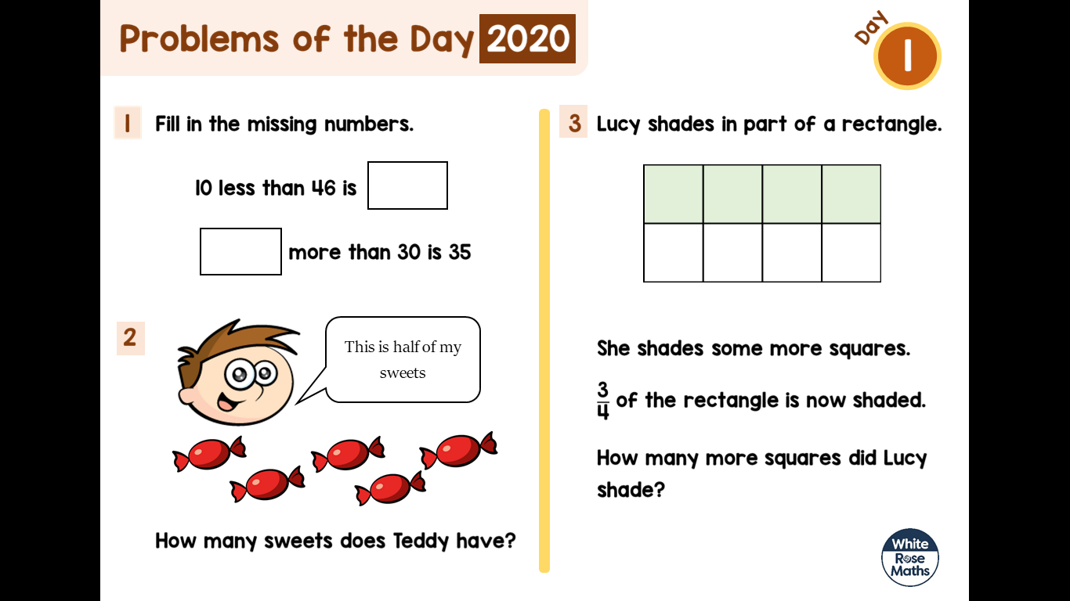
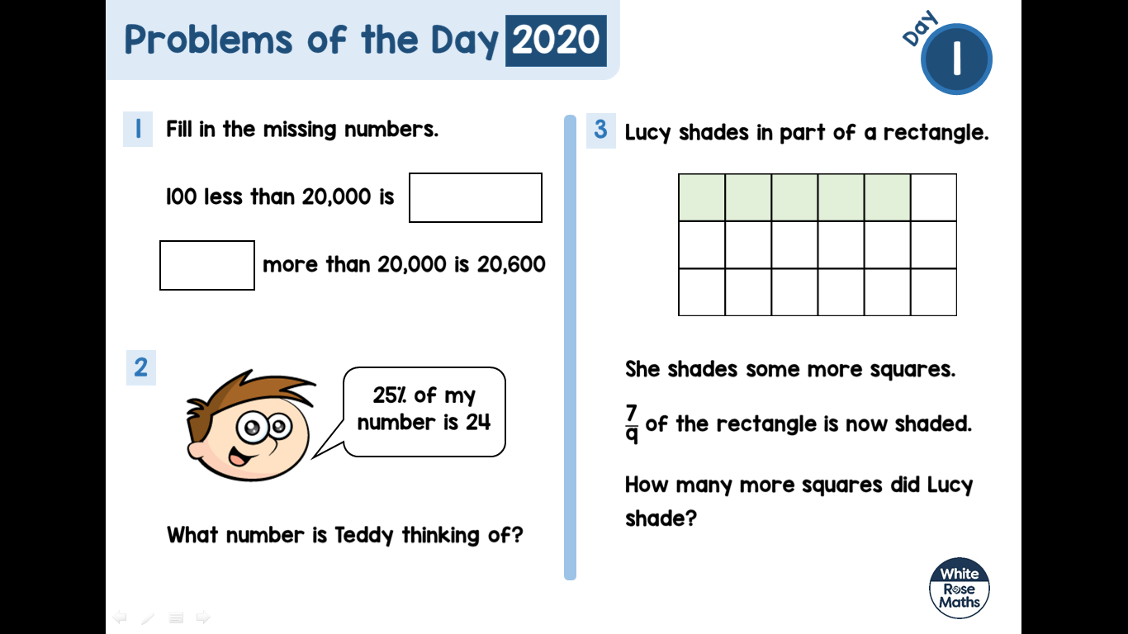
Literacy

- Write 3 sentences using the word of the day below.
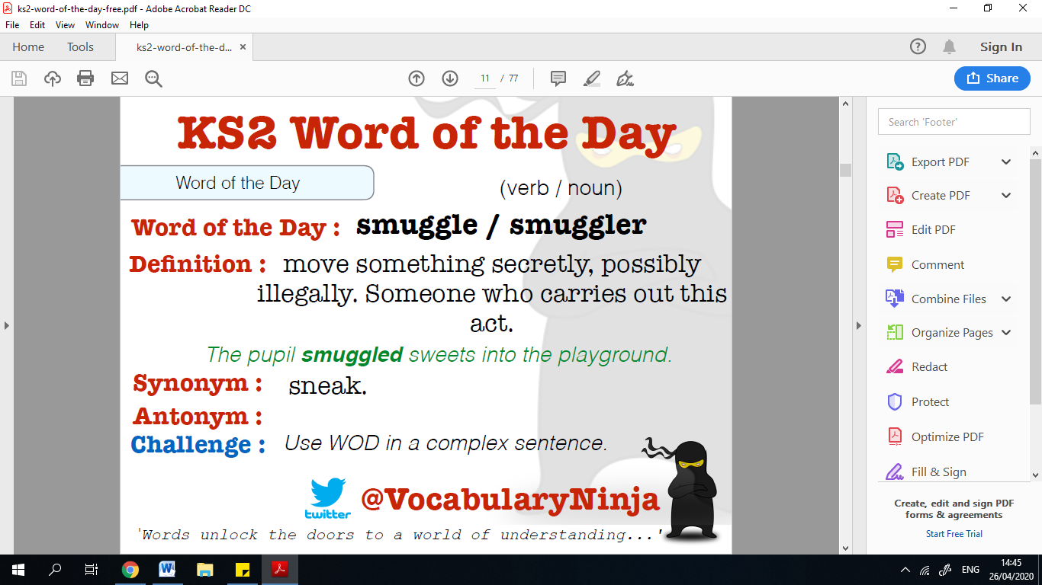

- BBC Bitesize – using apostrophes to show possession
https://www.bbc.co.uk/bitesize/tags/z63tt39/year-4-lessons/1
- Robin Hood
Uplevel these sentences
- Robin crouched on the rock.
- Robin drew an arrow.
- Robin drew the bow.
- He was strong.
Perfect Picture – can you research and then draw a medieval longbow man? Think carefully about his clothes and weapons. You could even write some instructions on how to fire a longbow.

Across the Curriculum

- French Numbers 20-50
https://www.youtube.com/watch?v=wlYqz2unHKc
- BBC Bitesize – Science – States of matter
https://www.bbc.co.uk/bitesize/tags/z63tt39/year-4-lessons/1
- STEM – In this activity, you will use recyclable materials to make your own wall marble run. A marble run is a fun toy and a great way to learn about physics concepts like kinetic and potential energy. Do you think your marble will make it to the end of the track?
https://www.youtube.com/watch?v=zTTuB_afFyQ

