Today’s Maths challenge!

What 2 objects would come next in this pattern?

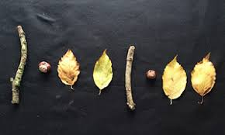

Using natural materials or concrete objects around the house can you create your own pattern?

Once you have created your pattern, can you continue your pattern by drawing it in your jotter?

LI. To create a pattern

SC. I can create with 3 or more objects

I can continue a pattern with 3 or more objects

I can draw my own pattern