Wednesday 29th April - French: Restaurant Foods

Today you are learning about restaurant foods.

Click on the link below:
https://www.french-games.net/frenchlessons?topic=Food%20-%20restaurant&level=primary
When the website has loaded click on the blue button that says ‘Full Tutorial: All Activities’.
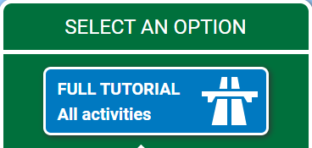

Click on the white ‘Start the tutorial’ button and follow the guidance given.
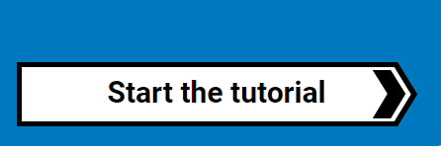
There should be four short lessons about restaurant foods, followed by 10 different games that you can play and then a test. Enjoy!

