Today’s Maths challenge!
Using natural materials or concrete objects around the house, Can you make different 2D shapes? How many vertices? How many sides?
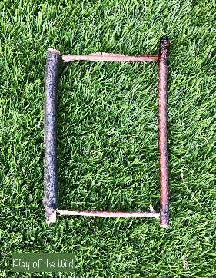
e.g. Rectangle-
4 sides
4 vertices
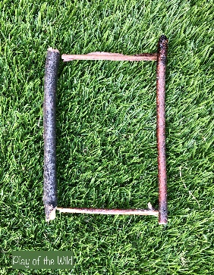

Can you make a hexagon, pentagon and octagon and record the numbers of vertices and side?
What other 2D shapes can you make?
Can you make a circle out of twigs?

LI- To identify the properties of 2D shapes
SC- I can make 2D shapes
I can identify how many sides a 2D shape has
I can identify how many vertices a 2D shape has

