Today’s Maths challenge!
Using natural materials or concrete objects around the house, Can you make an array and write the corresponding multiplication calculation? How many arrays can you build?
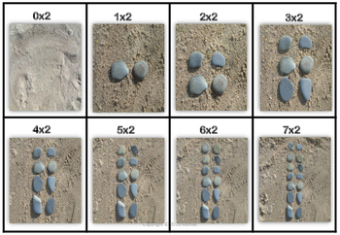
LI- To build, describe and count an array
SC- I can build an arrays using concrete materials
I can write the multiplication sum for each array
I can count the total amount in each array

