**Literacy lesson week 3 (part 3 of 3)**

Today we will swap postcards! I have written a postcard example from one friend to another. I’d like you to read this then write a reply pretending you are friends. Use your reply to me to help you. You can write a comment here or post pictures of your work on Twitter. Remember, you don’t have to use a real postcard. A piece of paper will be fine. Thank you.

LI - to show the purpose of my writing.

SC - I can include the main features of a postcard.

I can include who the postcard is to and from.

I can include a general statement, at least one fact and a farewell message.

I can respond to a question appropriately.

How do you feel you did today?

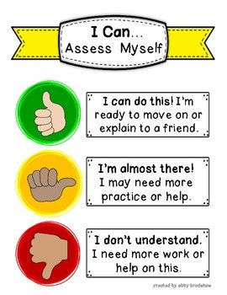

EXTRA CHALLENGE:

Royal Mail are asking the nation to show support for your postie by giving them a ‘thumbs up’.This can be in real life (but please keep a 2m distance!). You can support your local postie with the following free colouring pages:

[https://www.royalmail.com/thumbsup](https://l.facebook.com/l.php?u=https%3A%2F%2Fwww.royalmail.com%2Fthumbsup%3Ffbclid%3DIwAR39wuHLftpg1NLBVuenCWvzbh02ohdcRe5NxCMkXnMG7GRDJbPNMKveKFY&h=AT3dh9LkRvrN0VNxT080e_l9ReqmVBpPVuwU8wf7dhSObq7T4gmPDHWkNONNJ0wkEYUNnHRA3y-nZzfSoYuDpPuS1Lj4zxyFH_DFZwdS_dFMDv1yFywkxT3g6ozmrb2Yuqz5Etw)