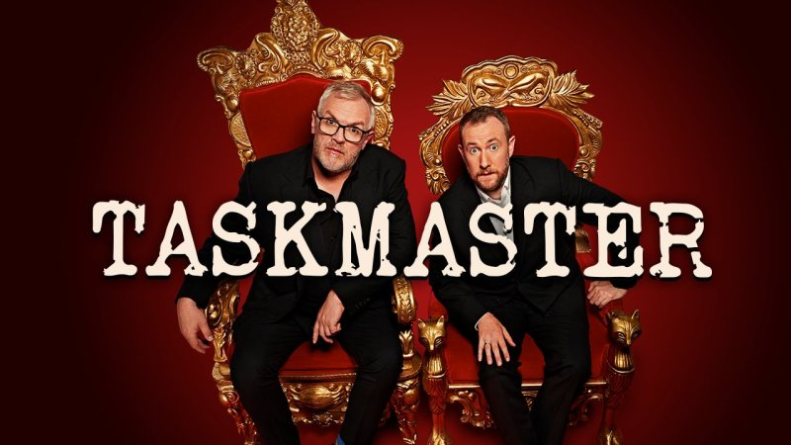
- Challenge 1: Make a vegetable look like a person!
- Challenge 2: Who can build the best fort?
- Challenge 3: Draw a self-portrait blindfolded or with your eyes closed!
- Challenge 4: Find something in the house that begins with every letter of the alphabet and then fit them all on a dinner plate!
- Challenge 5: Take a picture of your teddy / toys (or pet) doing something human.

Challenges will be updated throughout the term.

