- Roll the Die/Dice
Roll a die/dice and complete the activity. You can do it with a partner or on your own. You can do it as many times as you like. If you don’t have a dice, you could write numbers on scrap paper and choose one each time.

- 10 Jumping Jacks

- 10 Push-ups 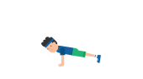

- 10 Sit ups

- Jog on the spot for 10 seconds

- Jump on the spot for 10 seconds

- Touch your toes 10 times

- Cosmic Kids Yoga – Pokemon theme
https://www.youtube.com/watch?v=tbCjkPlsaes

