Wednesday 22nd April - French: Groceries

Today you are learning about groceries.

Watch this video: Groceries in French

https://youtu.be/XLIE6hYGaF0

Click on the link below:
https://www.french-games.net/frenchlessons?topic=Food%20-%20groceries&level=primary

When the website has loaded click on the blue button that says ‘Full Tutorial: All Activities’.
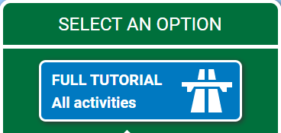

Click on the white ‘Start the tutorial’ button and follow the guidance given.
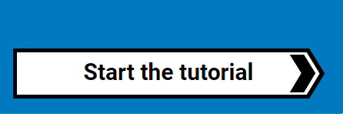
There should be four short lessons about groceries, followed by 10 different games that you can play and then a test. Enjoy!

