Literacy | Social Studies | Technologies
- Write a list of adjectives to describe different weather, e.g. hot, rainy, damp etc.  - Find your favourite book about weather. This could be a non-fiction or fiction book. Be ready to tell the class what it’s about and why you like it.  - Lots of sayings or rhymes tell us about the weather, e.g. it’s raining cats and dogs. Find two different weather sayings or rhymes and explain what they mean. | - Watch a weather forecast. Think about how today’s weather will affect a farmer, a fisherman, a postman or woman and you this week.  Write and/ or draw what you have found.  - Find a news story about the weather and how it has affected people.  - When can our weather be dangerous? Describe how weather can be dangerous and think about how we can keep safe. | - Create a menu for a picnic for your favourite season of the year. What would you eat and where would you eat it?  - Design an outfit suitable for a particular type of weather. Note what each item of clothing is,  what it could be made of and why it is suitable to wear! Think about the materials you would use.  - Design the ultimate umbrella (or another super weather object!) What features would it have? What would it look like? Why would it be better than any other?
Expressive Arts | Homework Choice Grid  Weather | Expressive Arts
- Using media of your own choice, e.g. pen, paint or materials for collage, create a weather picture.  - Make a seasons picture that shows how a scene can change  throughout our four seasons Spring, Summer, Autumn and Winter.  - Find a weather picture you like created by a famous artist. Be ready to describe the image, say how it makes you feel and why you like it. |  | - Prepare a weather forecast (like on TV) to share with your classmates. You can film it and share it with the class if you wish.  - Learn or make up a new song about the weather.  - Find a famous weather song you like. Be ready to say how it makes you feel and why you like it.
Mathematics | Health and Wellbeing | Outdoors
- Keep a weather record for a week e.g. highest temperature each day, amount of rainfall each day, wind strength each day and use this information to complete a bar graph in class.  - Find out what time the sun comes up and the sun sets. Write down these times for a week. Are the times always the same? | - Find out about different kinds of jobs or work that people do that are linked to the weather.  - Find out how to stay safe in dangerous weather conditions e.g. during a lightning storm.  Draw a picture or make a poster to show people what they should or should not do. | - Have a walk around your local area. How can you tell what season we are in? Write or draw what you have found.  - Look at the clouds! Can you take a picture or draw and describe the clouds you see? Take the  information into school and we can identify the clouds you have seen.
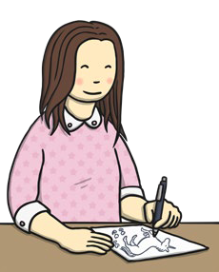
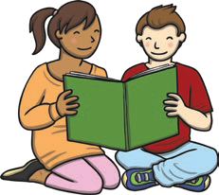
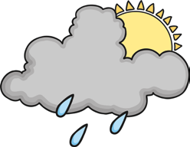
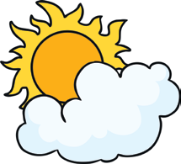
visit twinkl.scot

