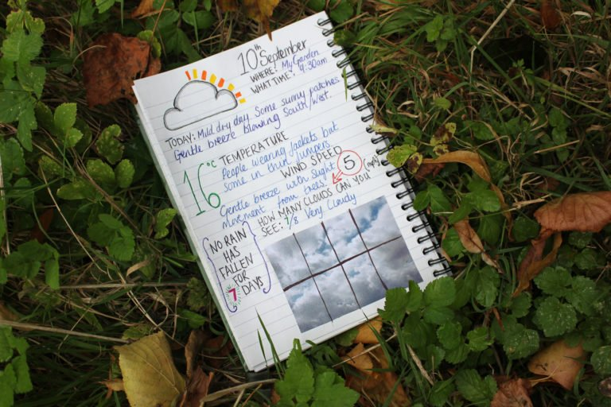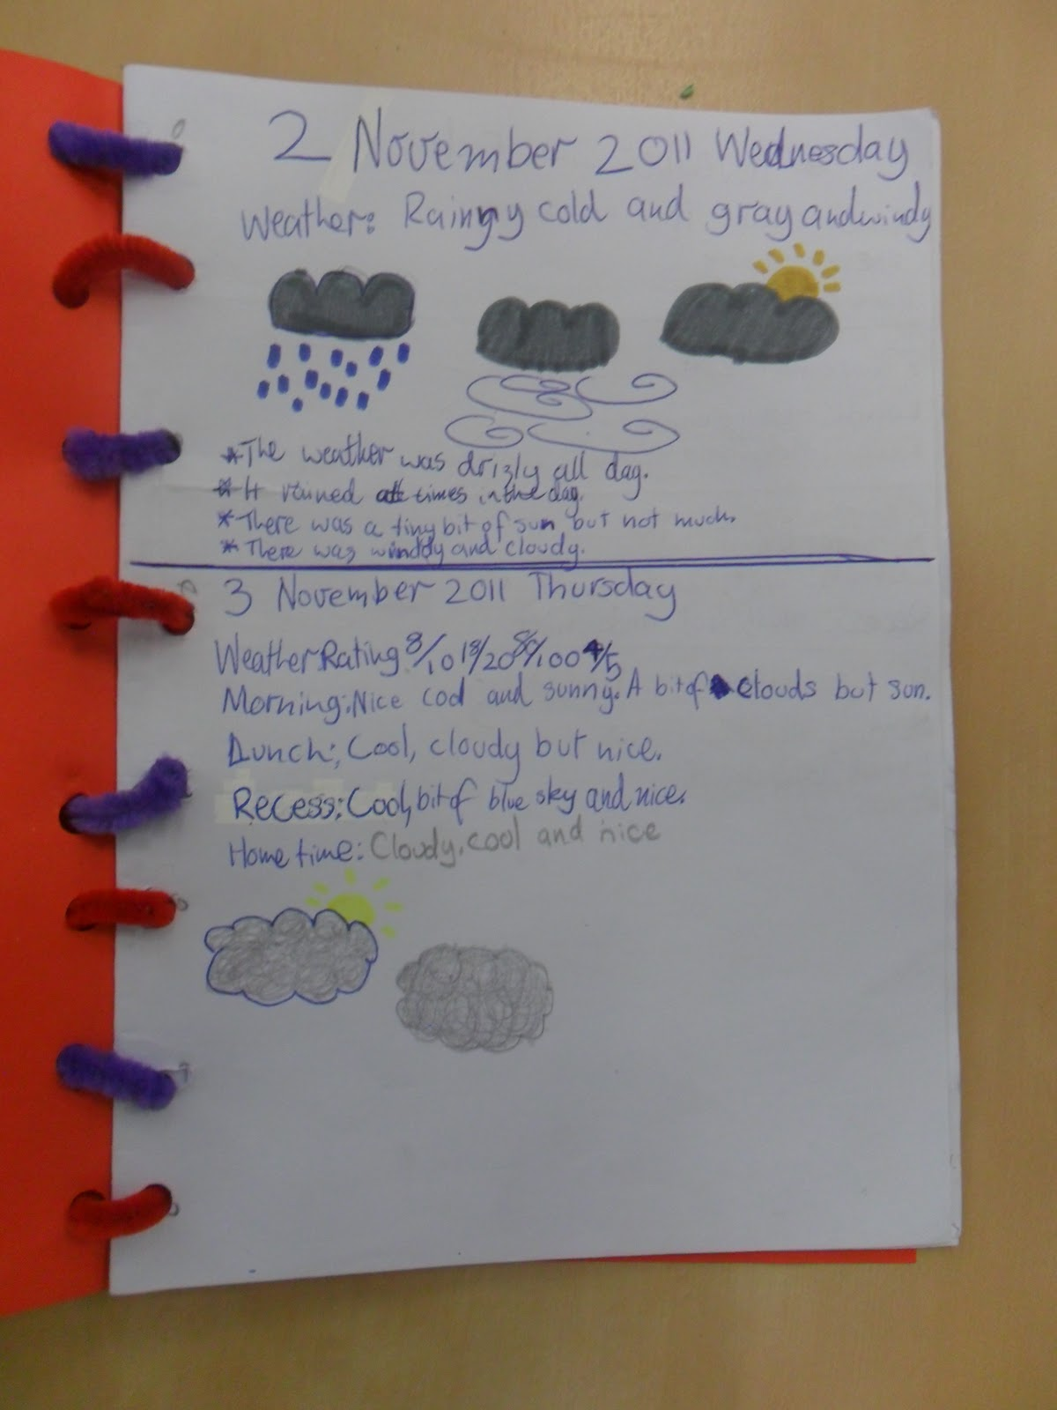Weather Diary

Here are some examples of weather diaries. You can make yours as detailed as you wish and could include photographs too.

Create your own weather diary using paper which you have at home or your purple free writing jotter. You should aim to record the weather each day as part of your Literacy activities. Give as much detail as possible, using adjectives and even pictures to make your diary entries more interesting.