Draw a picture for each of the words with “ee” in it.

|  |  |
| --- | --- |
| bee |  |
| week |  |
| seed |  |
| beep |  |
| feet |  |
| weep |  |
| weed |  |

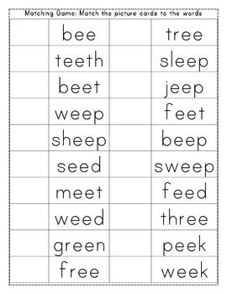

Harder examples:

|  |  |
| --- | --- |
| jeep |  |
| sleep |  |
| green |  |
| tree |  |
| three |  |
| sheep |  |
| sweep |  |
| free |  |
| teeth |  |
| cheese |  |