Tuesday 31st March 2020
Daily Activities

Below is a list of some ‘celebrity classes’ which you can engage with throughout the next couple of weeks.
9:00 | PE with Joe Wicks | Youtube.com/thebodycoach
10:00 | Music with Myleene Klass | Youtube.com/myleenemusicklass
11:00 | Science with Maddie Moate | Youtube.com/maddiemoate
11:30 | Dance with Oti Mabuse | Youtube.com/otimabuseofficial
13:00 | Maths with Carol Vorderman | Themathsfactor.com
14:00 | History with Dan Snow | Tv.historyhit.com
15:00 | English with David Walliams | Worldofdavidwalliams.com
17:30 | Food Tech with Jamie Oliver | Channel4.com/keepcookingandcarryon

Literacy
Writing – Taking Flight
L.I - we are learning to rewrite a narrative in first person
S.C – choose first/second level targets below to help achieve your learning intention – try your best to include as many I CAN statements in your writing

Task – Watch the clip below – Taking Flight

https://www.youtube.com/watch?v=Gj6V-xZgtlQ

Once you have watched the youtube link, you are going to imagine you are Tony and rewrite the narrative from his perspective. Remember it should be written in first person (I or we)
SECOND
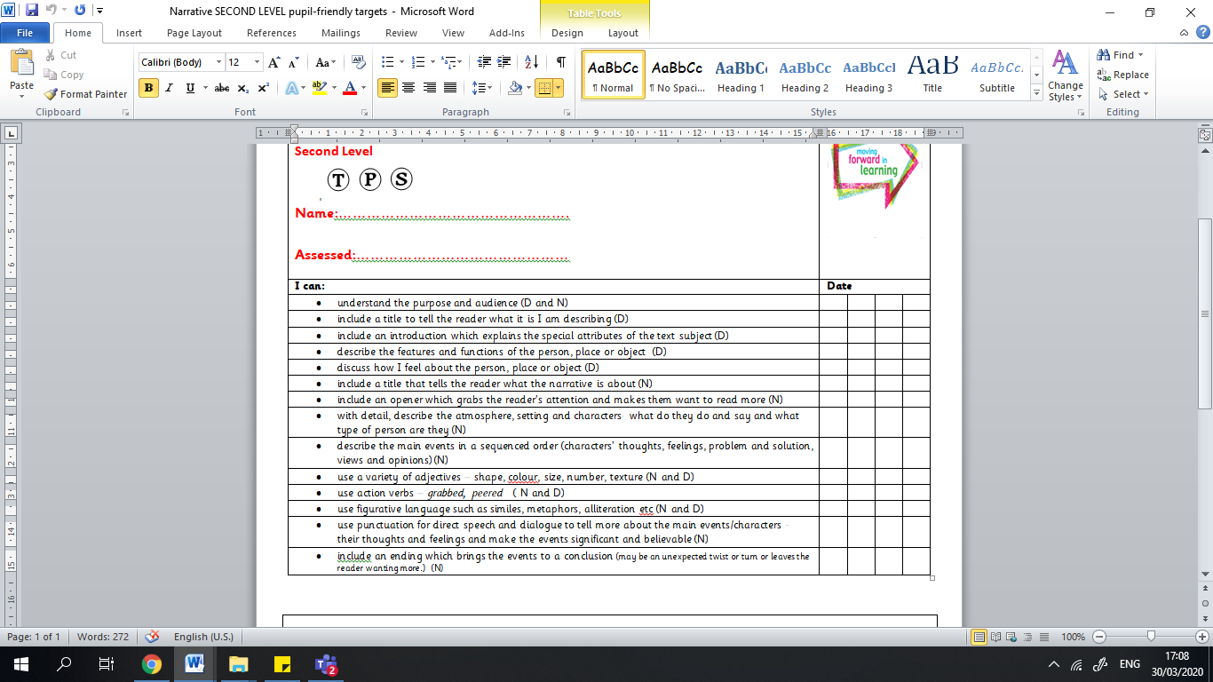
FIRST
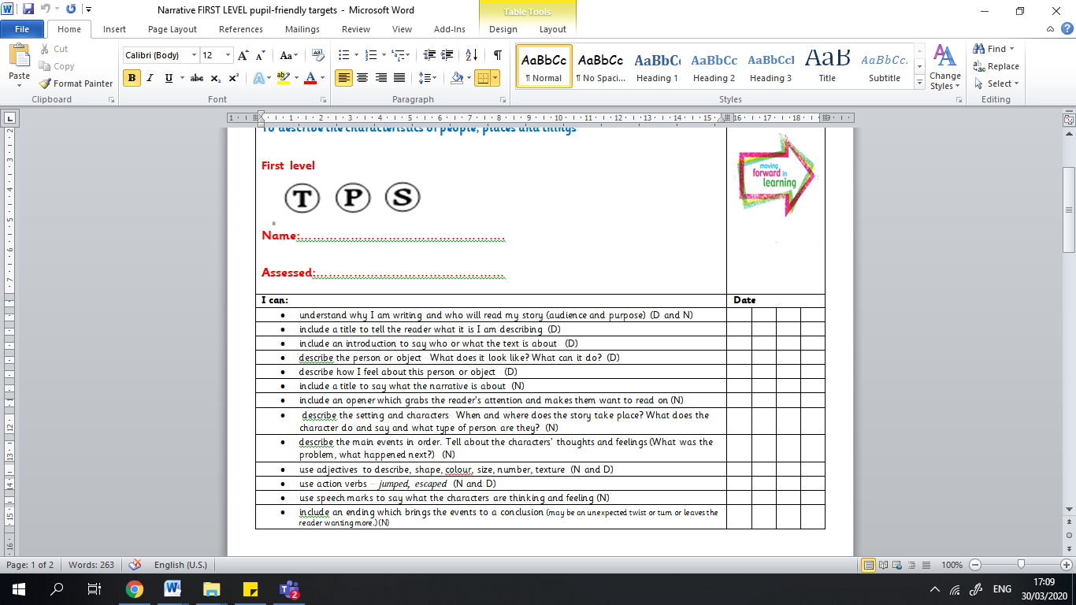

Numeracy

Mental maths
LI – we are learning to apply our knowledge of numeracy strategies to solve calculations
Complete Splat – 2.3
Complete Esti mystery – two of hearts

(Splat and Esti-Mystery found in Files – Numeracy and Maths)

Times tables
L.I we are learning to recall table facts accurately and quickly
Play boardgame you created yesterday with a family member.

Easter Maths
Choose 2 Easter challenge cards, you will find these in Files/Blog/Email - choose the level first/second

Learning across the Curriculum​

Your afternoon Easter activities…

Watch the clip on The Easter Story

https://www.youtube.com/watch?v=0PSgoPdKQFQ

Task 1 – take notes of the key points throughout the story.
Task 2 – using these key points create a comic strip retelling the story.
Task 3 – write your own Easter message for our school and community.

