Monday 30th March 2020
Daily Activities

PE with Joe Wicks 9-9:30am

or
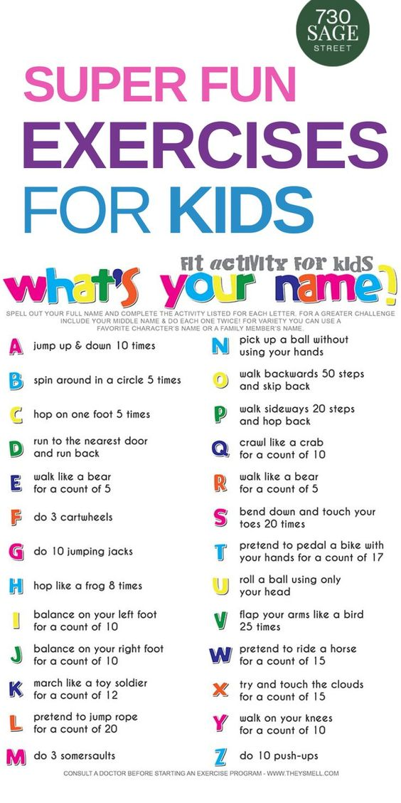
Literacy
Spelling
LI – we are learning to spell most words correctly using patterns and sounds
Task – Draw a big flower. Write each of your spelling words on one of the petals. Choose 3 of your spelling words and find synonyms for them. (Remember synonyms are words that are similar or have a related meaning)
Spelling Words – Common words
Awesome Apples | Positive Pineapples | Wonderful Watermelons | Keen Kiwifruits
the  he  we  to  in  she  day | time  once  come  night  made  again  round | front  fact  decided  street  contain  course  nothing | language  thousands  government  machine  material  carefully  special

Grammar
LI – we are learning to change singular nouns to plural nouns
We have done some work on singular and plural nouns, so this week we will do a bit of revision. Watch the Youtube clip below to refresh our memories the strategies used when changing singular to plural.
REMEMBER – NEVER ADD APOSTROPHES TO PLURAL WORDS!
https://www.youtube.com/watch?v=BI1Syz9I2n0
Task – your job is to find 10x objects around your house that are singular and change these to plural. Today we will change singular nouns to plural nouns ONLY adding ‘s’ and ‘es’
For example:
Singular | Plural
spoon | spoons
potato | potatoes
Reading
LI – we are learning to summarise
SC – to be able to condense the key message
- to be able to identify the most important information

Task – Choose a book of your choice and either read a chapter/whole book and summarise what you have read. Read back your summary and ensure it makes sense…have you included the SC?

Numeracy

Mental maths

LI – we are learning to apply our knowledge of numeracy strategies to solve calculations

Task – choose a chilli mental maths challenge below (you can do all 3 if you wish)

Mild | Spicy | Hot
1. What is 1 more than 7?  2. What is the total of 3, 2, 3?  3. How long would it take you to sharpen a pencil, 1 minute or 1 hour?  4. Two lots of 2=  5. 8 plus 8 = | 1. Nineteen minus 6=  2. Write 116 in words  3. What are 5 lots of 6?  4. How many halves in a whole?  5. 1kg + 500g = …..g | 1. 90cm +5cm = …..cm  2. Write 3840 in words  3. Frank bought 0.5kg of bananas. Write this as a fraction.  4. There are 32 children in our class and 8 in each group. How many groups are there?  5. I bought 7kg of carrots at 50p per kg, and 1kg of pumpkin at 25p per kg. How much did I spend?

Times tables

L.I we are learning to recall table facts accurately and quickly
Choose a times table you need to work on. Create a boardgame for this times table (A4 size will be enough) Use the boardgame to help you learn your chosen table.
Decimals
LI we are learning to understand decimals
SC – to use knowledge of place value to create a decimal number

Choose your decimal challenge – you will need to zoom in to see the questions

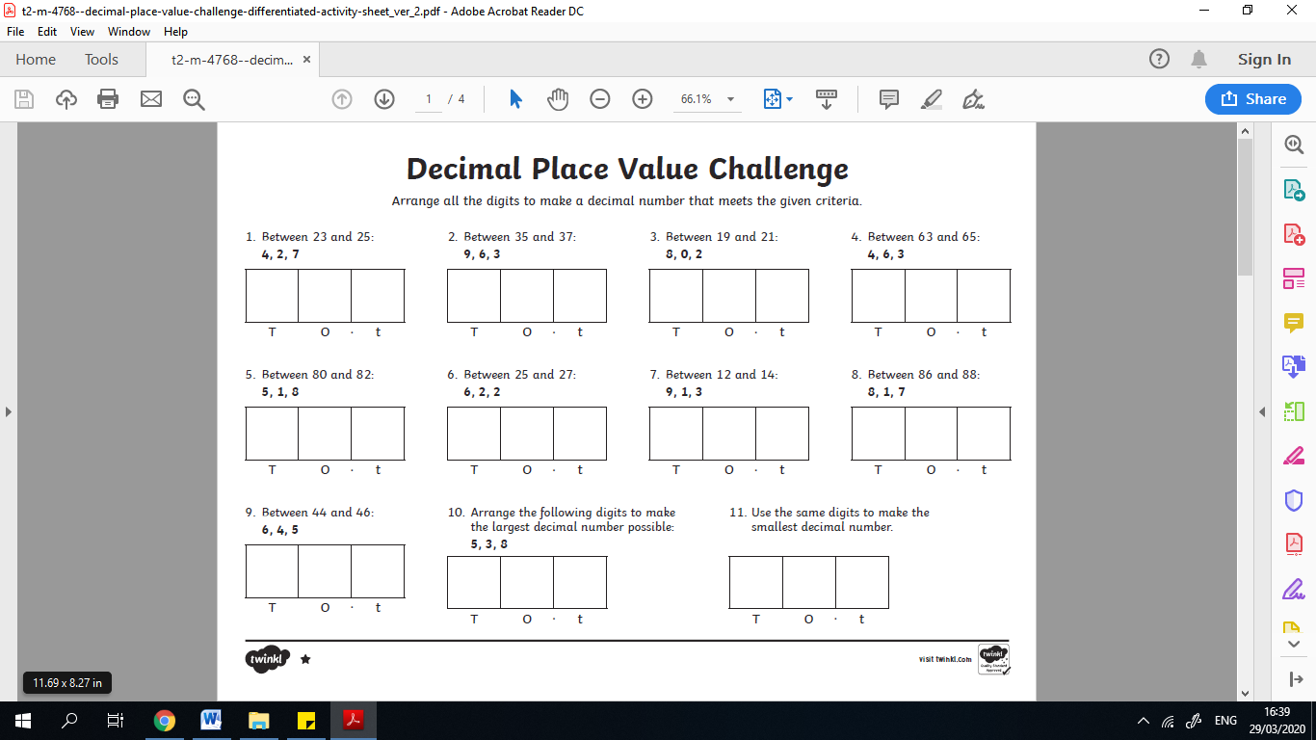
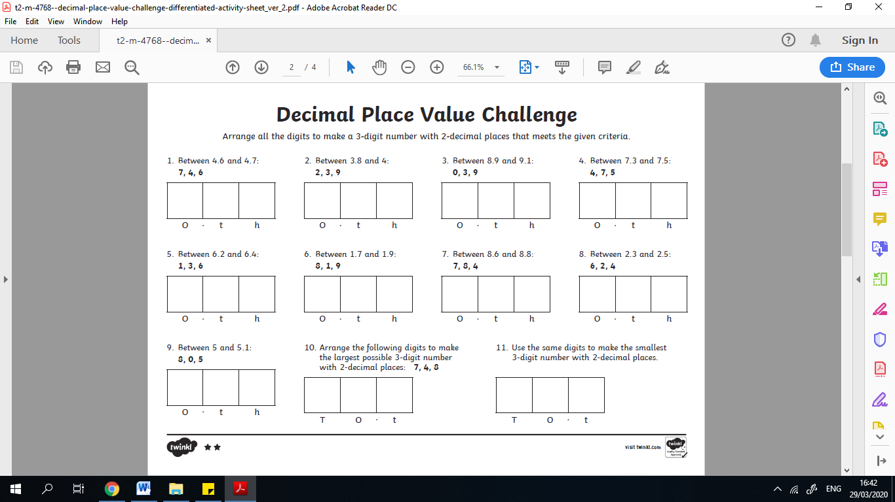
Learning across the Curriculum​

As this is our last week before the Easter holidays our afternoon activities will consist of Easter fun!
Your first challenge this week is to find out how Easter is celebrated in different parts of the world.

Task 1
You must research at least 3 countries and their Easter traditions

Task 2
Create a SWAY presentation to display this information

Task 3
Create a quiz based on the information gathered

Task 4
Share your SWAY presentation with a family member and then quiz them on what they have read!

If you cannot access SWAY (in the waffle) then a PPT/Word document is fine

Enjoy!

