Friday 27th March 2020
Daily Activities

PE with Joe Wicks 9-930am 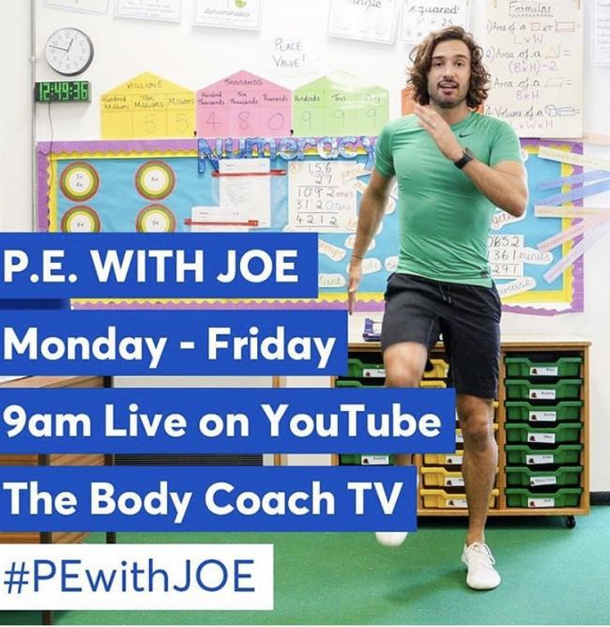

Or
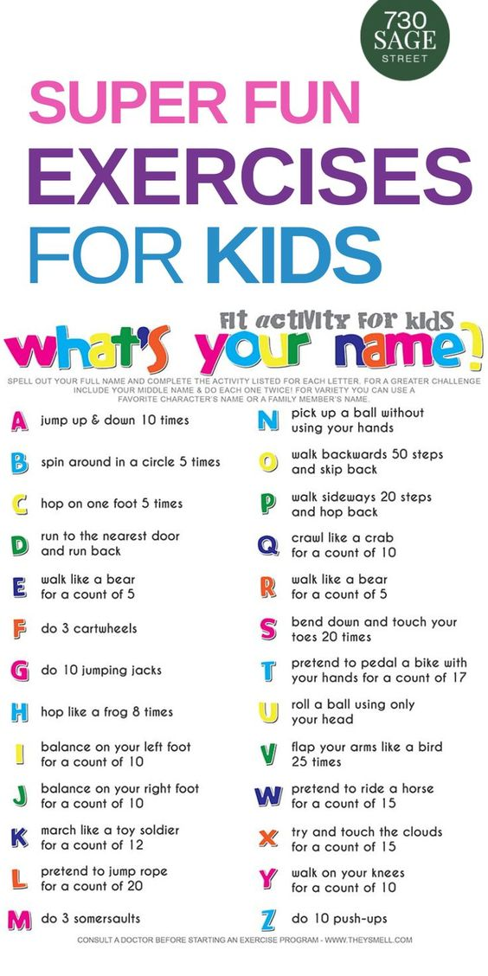
Well done completing your first week of home learning! This is a new experience for us all and you should be very proud of what you have achieved!
Today you will get the choice to choose your learning. Below you will find a learning grid. You can choose 3 activities to complete throughout the morning. Have Fun!

Write a postcard to a friend or relative in self-isolation.  Cut out the card, draw a picture on the front and write a message on the back. If you can post it – even better! | Write a letter to a key worker, thanking them for helping everyone. | Go on a shape hunt around the house. How many different shapes can you find? What are they good for? Stacking/rolling/joining etc.
Create a boardgame to play – this can be literacy/numeracy based. | Complete a jigsaw or puzzle | Create a leaflet/poster/video for a younger friend/sibling/relative with activities to keep them entertained during school closures. Then do some of these activities!
Free writing Friday – let you imagination run wild and write about something that interests you. This can in the form of a news reports, letter, persuasive, poster etc. | Make playdough using water, oil, flour and salt (there are lots of recipes online). How many different shapes can you make? | Explore coding by setting the task of writing instructions for a robot. A family member becomes the robot and tests out the instructions. Were the instructions precise enough?
Make something using Lego/craft material – this can be something that interests you. | Go outside and use chalk to draw around someone's body.  Can you draw what is inside your body? What does each part do? | Create a rainbow collage by collecting coloured materials from your garden or home.
Design and make a paper aeroplane that will travel the furthest.  Does changing your design make it go further? | Make a list using words/drawings to find all the things in your home that use electricity.  If you could keep only one item which would it be? Why? | Choose a novel of your choice and find 5 unfamiliar words – look up the definitions in the dictionary.

