Science: Science: Planet Earth
Living and Non-living

Learning Intention:
We are learning to understand the difference between living and non-living things and determine if they are a plant, animal or other using a variety of features.

Success Criteria:
Say: I can explain the difference between a living and non-living thing.
Write: I can write facts about living and non-living things.
Make: I can go on a scavenger hunt and find living and non-living things
Do: I can sort objects into living and non-living things.

Is it Alive? Have a look at the photo below and identify which objects are alive.
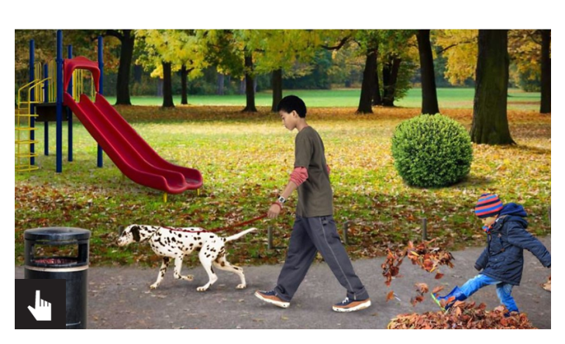
Questions
- What makes living things different from non-living things?

Watch this video clip on living and non-living things
www.generationgenius.com/?share=35C78
Key Facts
- Living things grow, take in nutrients and reproduce.
- Non-living things don't do those three things.
- There are many living and non-living things all around us.

Questions
- What do we mean when we say something grows?
- What do we mean by the word nutrients?
- What do we mean when we say something reproduces?

Consolidation Activity

Go on a scavenger hunt and find examples of living and non-living things.

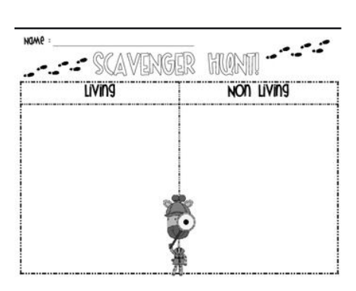

Take a photo or the things you collect / observe or write them down, sorted into living and non-living.

Complete the quiz to see what you have learned today.

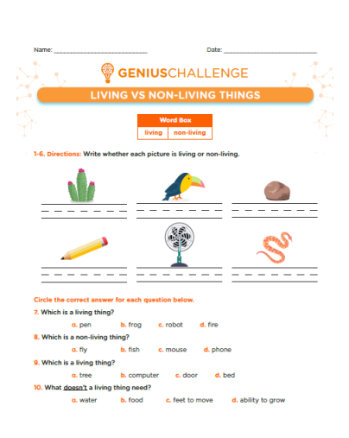
Did you meet the success criteria?
Success Criteria:
Say: I can explain the difference between a living and non-living thing.
Write: I can write facts about living and non-living things.
Make: I can go on a scavenger hunt and find living and non-living things
Do: I can sort objects into living and non-living things.
Share something you have learned in science today with someone in your family.

