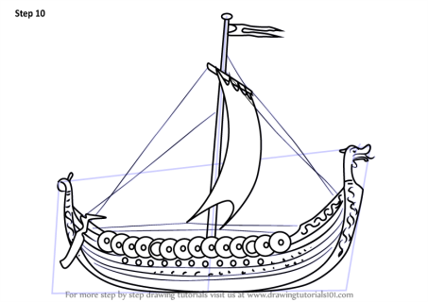
Thursday 26th March 2020
IDL & Outdoor Learning
IDL: 1.15-2.15pm
Activity 1
Complete your research activities from Monday about Vikings. Please post your poster/ model onto our TEAMS page if you can or send it to your teacher via the blog and they will post it for you.
Include an explanation with your model or poster about how you made it.
Activity 2
Enjoy one of the drawing tutorials below and post your creation to our TEAMS page or add it to your free writing jotter to share when we are back at school.
Viking longship - https://youtu.be/sEQn3vMD05g
Viking - https://youtu.be/1o2iFyeDr6M
Viking dragon - https://youtu.be/gocVNBF-_os

Now find somewhere cosy to sit and enjoy listening to one of the stories to go along with the Viking character that you might have chosen to draw this afternoon .
Storytime – Viking Vik - https://youtu.be/ZNDQOZ0fIRA
Outdoor Learning
2.15-3.15pm
Kids Gone Wild
Bug Hotel Challenge

https://prezi.com/view/0LhI69WNkNTSdjW372An/

Watch the slideshow above and then have a shot of making your own in the garden!

