Choose one activity:
Set the table for a meal. Make sure you wash your hands!  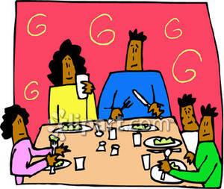 | Draw all fruit and vegetables you have eaten today.  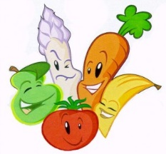 | Draw three things that make you happy.  