Science: Planet Earth

How plants grow

**What have we been learning?**

So far in our planet earth topic we have been learning about living and non-living things and food chains. What can you remember about this?

**Learning Intention:**

We are learning to understand what plants need to grow.

**Success Criteria:**

**Say**: I can explain what plants need in order to grow.

**Write:** I can write facts about the best conditions for plants to grow.

**Make**: I can draw a comic strip to show how to care for a plant.

**Do**: I can plant a seed and use what I have learned to help it to grow.

What do you think?

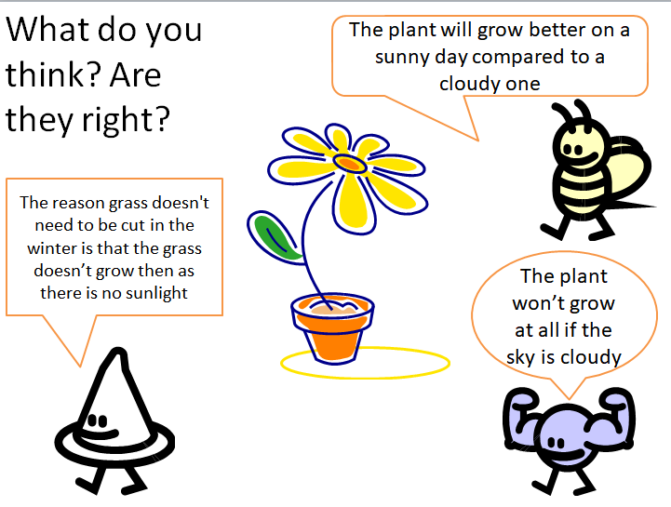

Question

* What will happen if a plant does not get any water?

Watch this video clip on what plants need to grow

[www.generationgenius.com/?share=44DA4](http://www.generationgenius.com/?share=44DA4)

Key Facts

* Plants need the right amount of water and light to grow best.
* Soil quality can affect how well plants grow.
* To find the best conditions you need to experiment.

Questions

* What did you notice about the plant that was given much more water than the others?
* What did you notice about the plant that was given much more light than the others?
* What advice would you give to someone who wants to grow a healthy plant?

Consolidation Activity

If you have the resources you could plant a seed in a small pot and look after it to help it to grow using the information you have learned. If not, why don’t you draw a comic strip to show how you would look after a plant to help it grow.

Take a photo of your plant / comic strip or write notes to explain what you achieved.

Complete the quiz to see what you have learned today. 

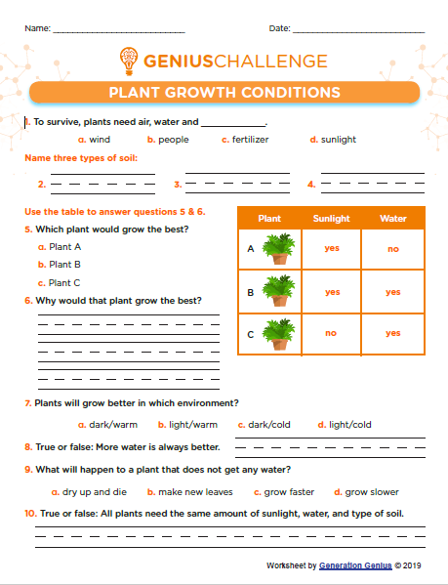

Did you meet the success criteria?

**Success Criteria:**

**Say**: I can explain what plants need in order to grow.

**Write:** I can write facts about the best conditions for plants to grow.

**Make**: I can draw a comic strip to show how to care for a plant.

**Do**: I can plant a seed and use what I have learned to help it to grow.

Share something you have learned in science today with someone in your family. 

Lots of people are growing their own plants and vegetables to reduce the need to go to the supermarkets. Can you grow something you could eat….