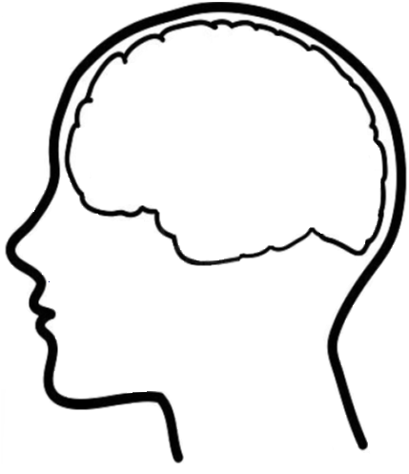

KWL Chart

**?**

Know __________________________________________________________________________________________________________________________________

___________________________________________________________________________________________________________________________________

Want to Know

Learned