
UPHALL PRIMARY SCHOOL
UPHALL PRIMARY SCHOOL and ELC
Crossgreen Drive, Uphall,EH52 6DS
Tel No: 01506 852516
e-mail:wluphall-ps@westlothian.org.uk
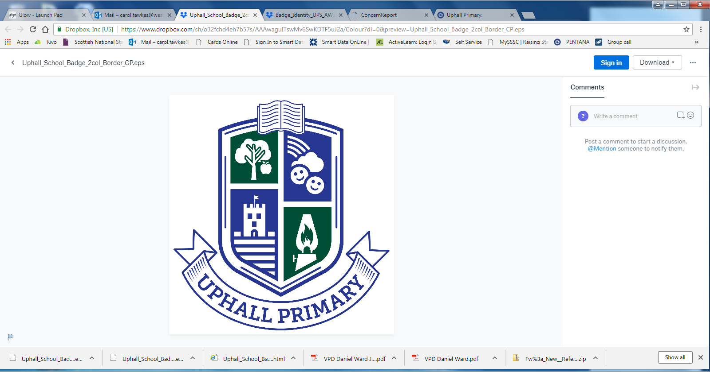

Headteacher: Ms C Macrae

Friday 20th March 2020

Dear Parent/Carer

As we enter a period of school closures, the following arrangements are in place to ensure that your child’s learning can continue throughout this time.

The key source of learning will be using online platforms (virtual learning environment) however alternative arrangements will be made by individual schools for pupils for whom online learning is not suitable.

For children attending the nursery, suggested learning experiences that can be completed within the home will be provided on the school/nursery blog: https://blogs.glowscotland.org.uk/wl/uphallprimary/

For children in P1-P3, teachers will provide a set of appropriate learning experiences that can be completed at home. These will be shared through our school blog: https://blogs.glowscotland.org.uk/wl/uphallprimary/ Your child has been provided with a numeracy/maths, literacy/language jotters to record their learning and there will be an opportunity for them to share this when they return to school.

Children in P4-P7 are part of their class Microsoft 0365 Team, which can be accessed through their Glow account. Your child requires their Glow username and password to access their Team, and they are familiar with how to use this platform. Information for parents on how their child uses Teams is available at: bit.ly/wlglowguide

It is expected that your child accesses their Team daily to engage with the learning experiences being provided by their teacher. The platform provides a function for your child to share their learning with their teacher and receive feedback where appropriate and support where required.

The use of Teams for communication is for learning purposes only between staff and pupils and ensures the safety of all users.

Parents / Carers who have any questions or require further information should use the following contact details: wluphall-ps@westlothian.org.uk

Our school team will continue to provide all available support to your child and family where we can during this challenging period.

Yours sincerely

Catriona Macrae
Head Teacher

