Red Nose
Day
2022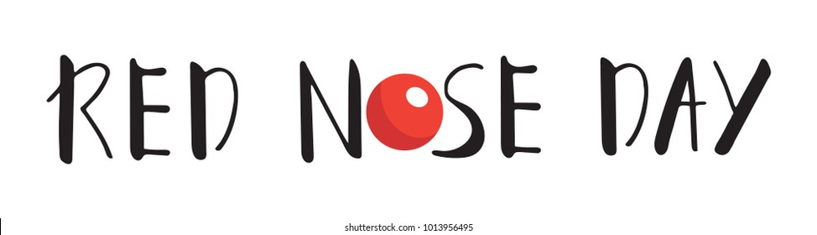
We will be selling red noses in school for £1.50 from Monday 14th March.
Children can dress as a super hero or dress down on Thursday 17th March - £1 donation to Comic Relief.

