

Stoneyburn Nursery

**September Newsletter**

**Welcome**

We would like to give a warm welcome all our new children and families to our new nursery! We have had a great first few weeks getting know everyone and our new nursery which we all love and where everyone is included.

Below is our GIRFEC characters, these will be taught to the children over the coming weeks. They will be encouraged to learn and understand the meaning of each character.

|  |  |  |  |
| --- | --- | --- | --- |
| Safe | Healthy | Active | Nurtured |
| our-creative-journey-spinner-2-small | healthy | active | nurtured |
| Achieving | Respected | Responsible | Included |
| achieving | respected | responsible | included |

**Groups/Keyworkers**

Yellow group – Miss little

Purple group – Mrs Edbrooke

We also have Mrs Kelly, our wonderful pupil support worker ☺

Please ask a member of staff if you are unaware of which group your child is in.

**Learner’s Journeys**

You should have now had an email to set up your child’s Learning Journal, your child’s keyworker works very hard to ensure you can be part of the learning experience, especially at the moment when unfortunately you can’t come into the building, they will regularly update your child’s learning journal with observations and pictures of your child. There is also an opportunity for you to upload any pictures from home that link in with your child’s development or any special occasion that you would like to share with us which we look forward to seeing.

**Nursery Clothing**

As part of our free flow nursery experience, children are offered outdoor play in all weathers – although we are very lucky to have our pergola which can keep us covered if need be, we kindly ask parents to please provide, where possible, appropriate clothes for all weathers.

Could we also kindly ask that all clothes, shoes, bags etc are labelled with the child’s name as we encourage the children to get ready independently as much as possible, therefore clothes etc can get mixed up at times and this helps us to ensure nothing goes missing.

We are also trying to make a stock of spare clothes as we currently have none due to being so new, if anyone has any old but usable clothes they would like to kindly donate, please speak to a member of staff about doing so.

**Lunches**

As you are aware, the children now get offered a free school meal at lunch time, this is either a hot meal or a packed lunch option. Most of our children at the moment are bringing in their own packed lunch which is also an option, as we promote healthy eating in our nursery, could we please ask that you keep this in mind when packing your home packed lunches. Thank you for your help with this.

**Loose Parts Play**

“Children usually prefer play that stimulates their curiosity and gives free rein to their imaginations and creativity. We believe that one of the best ways to enhance their natural curiosity is to introduce a wide variety of materials we call “loose parts” into their play settings” – Lisa Daly & Miriam Beloglovsky

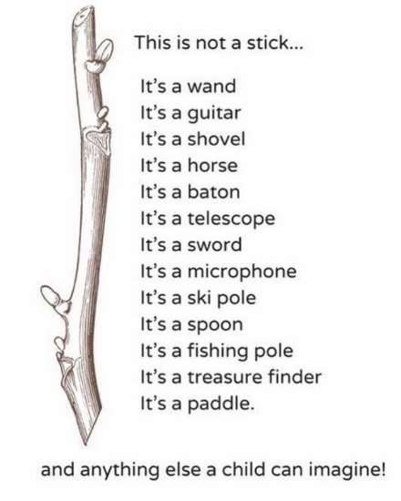Again as a new nursery we are starting to make a collection of loose parts to add into our setting for the children to experience. Below is a list of some of the items we are looking for and would greatly appreciate if anyone had any to donate to us,

* Wool
* Ribbon
* Any material
* Pots/pans
* Utensils
* House phone
* Garden pots
* Garden equipment – trowels etc

We look forward to working with you and your children and please remember we value your input and suggestions so please feel free to call or speak to a member of staff at any point if you have any concerns etc,

Many thanks, The Nursery Team.