T E R M

3

22-23
In Primary 4 this term we are focusing on

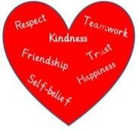
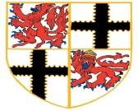

Health and Wellbeing
- Gods Loving Plan
- Wellbeing Wednesday
- PE focus
- Learning about Resilience

Literacy
- Scots Language
- Taking notes
- Writing Narrative/Descriptive
- Use common punctuation correctly
- Spelling – vowel digraphs

Developing our skills for life, learning and work
- Creating a presentation using PowerPoint
- Investigate how historical
influences can be found in
society today
- Exploring bridge designs and structures

Numeracy
- Review and revise known Times Tables
- Extend knowledge and use within Multiplication and Division
- Angles – acute, right and obtuse angles
- Naming the properties of 2D and
3D shapes
Developing our Faith

- Sacramental Preparation for those enrolled in the programme
- Exploring other World Religions
- Gods Loving Plan

Born for Greater Things

