Rapid Reading (Active Learn)
Go to https://www.activelearnprimary.co.uk/login.php?c=0
1st Screen 2nd Screen
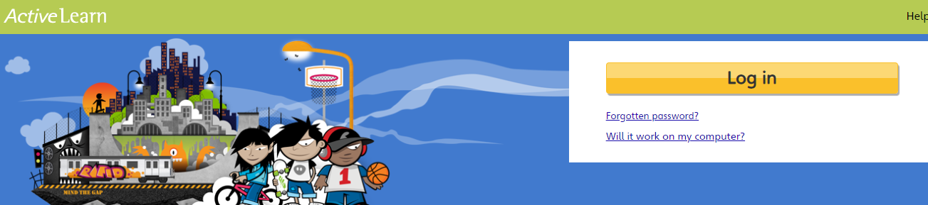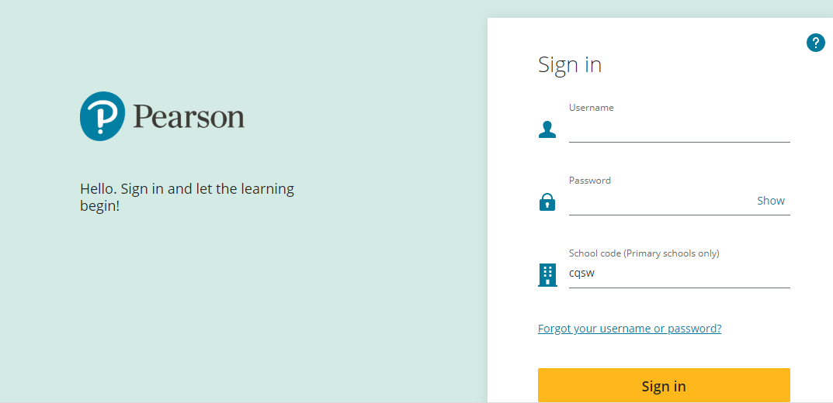
Follow the instructions below to log in.
User Name: your first name in small letters and the first letter of you surname (e.g. David Patterson would be davidp )
Password: book1
School Code: cqsw

Once you have logged in, you will have access to a selection of books that have been allocated to you.
I will let you know which book you should be working on at home each week.

I can see what you have been reading and how you have been doing on the questions, on my computer at home. I look forward to seeing all the great work you are doing!
Happy reading everyone.
Mrs Green

