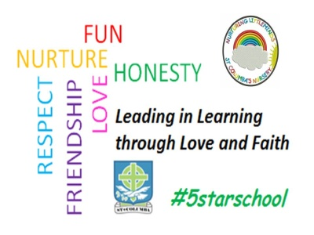

30th October2020
Dear Parent/Carer
We are very pleased that since schools have re-opened, almost all children and young people in West Lothian have had the opportunity to return to their schools. Although there has not been a return to normality in our schools, pupils have been able to resume their studies, and also meet up with their friends, in a safe environment. Our staff have been delighted to return to school with pupils.
We have already seen some changes in the national guidance that all schools in Scotland are following, and we will see further change from Monday 2 November.
The Scottish Government has introduced a new framework for tackling the Coronavirus pandemic. This involves each area of the country being placed in a different Level, ranging from 0 to 4. At each level, different steps are taken to limit the spread of Coronavirus. This includes some changes in schools.
West Lothian has been placed in Level 3, and as from Monday 2 November, the following changes will apply:-
- all staff and pupils should wear a face covering in classrooms during lessons in the senior phase (S4-6)
- parents or guardians should discuss with their GP or clinician whether children with the highest clinical risk should still attend
All schools will review the existing measures they have in place to reduce the spread of Coronavirus, and remind all pupils of the importance of complying with these measures.
Please help us reduce the risk to all pupils and their families by encouraging your child(ren) to follow all the instructions they are given to maintain their health, safety and wellbeing.
Here in St Columba’s we will continue to adhere to our risk assessments which have been already been communicated. In line with Government guidance, face coverings should be worn by parents and other visitors to the school site (whether entering the building or otherwise), including parents at drop-off and pick up-thank you for your support with this.
Yours sincerely
Fiona Smyth

