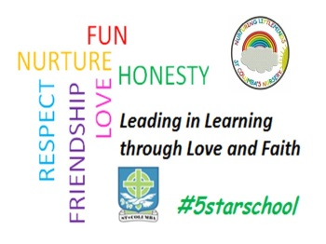
St Columba’s Nursery Class
Monday 10th August 2020
Headteacher Miss F Smyth

You should have received a group call to inform you of the planned phased return to nursery, shown below.
All returning nursery children will return to nursery on Wednesday 12th August. We cannot wait to welcome them back!
AM session: Doors open 8am/12.30pm PM session: Doors open 1.15pm Pick up times- flexible

We hope that you and your family have managed to have a good holiday and that your child is excited about coming back to school. We are looking forward to welcoming everyone soon.

A few changes to our setting
You will notice that there are yellow arrows guiding you to the nursery entrance. The nursery staff will greet you at the door. For health and safety reasons parents will not be able to enter the nursery.
If your child is upset there will be a comfort station available to the right hand side of the nursery door.
Nursery staff will ask you for an approximate pick up time so we can ensure your child will be ready for collection when you arrive.
Children can bring their bags with their change of clothes, but bags will be returned at the end of each day.
All day children can bring their packed lunches as normal
As far as it is safe to do so, children and parents/carers are encouraged to travel to nursery on foot, bike, scooter or park and stride. Parents are not permitted to use the staff car park.

Risk Assessment
Please be assured that the safety, health and wellbeing of our children and staff is our key priority and we will adhere strictly to advice from the Scottish Government and WL Council to ensure that everyone is safe and well.
The new risk assessment will include essential public health measures such as:
· enhanced hygiene and environmental cleaning arrangements;
· minimising contact with others and physical distancing for adults;
· wearing appropriate personal protective equipment where necessary;
· a requirement that people who are ill stay at home; and
· active engagement with Test and Protect. Please note that there is no requirement for children to wear a face covering or for physical distancing between children in a nursery setting.

Anyone with a high temperature, new continuous cough, loss of (or change in) sense of smell or taste, or who has had contact with a family/community member with symptoms, should not attend school. If a child begins to display these symptoms when in school they will be isolated and will be asked to return home and be tested.

Toys from home
Children should not bring toys from home into nursery. Children may bring a transitional object (comforter) if they need this to help settle in. We will then review every child and adhere to health and safety guidelines to ensure this is not transferred between children.

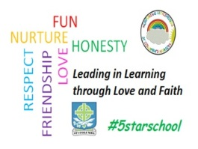
If you would like to speak to a member of staff, please call the school office to book an appointment. Parents should not enter the nursery building unless they have an appointment.

Please continue to check the app for further updates over this last week of the holiday. I am sure you will understand that this is a developing situation and things can change at short notice according to national and local guidance. You can also see a ‘Back to School’ animation on the WL Council website
https://westlothian.gov.uk/back-to-school

We look forward to seeing all our children this week. Thank you for your continued support. Please take care and stay safe!

Miss Smyth

