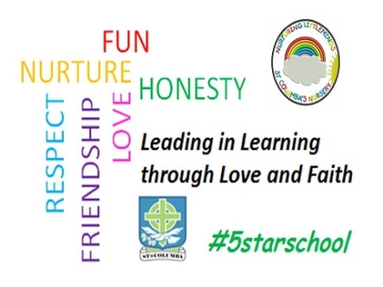
St Columba’s R.C Primary
Philip Avenue
Boghall
Bathgate
EH48 1NQ
Tel 01506 653822

Head Teacher – Miss Fiona Smyth

Dear Parent/Carer
We appreciate how difficult it has been for many parents to support their children at home, and would like to thank you for the many ways in which you have worked with us during the school closures.
You will have received communication from West Lothian Council yesterday and you will likely be aware of the Depute First Minister's announcement of the aim of re-opening all Scottish schools to all pupils on a full-time basis from Wednesday 12 August.

With this aim in mind, I would like to share with you our class structure and your child’s class teacher for August if a full return is achieved.

As previously shared with parents through our weekly update we are moving to 6 classes. Our classing structure is as follows:

- Primary 2/1 Miss Robyn Ivory
- Primary 3/2 Mrs Lisa Donnelly and Mrs Claire McIntyre (Mon-wed)(wed-Fri)
- Primary 4/3 Mrs Elaine Butcher
- Primary 5 Mrs Frances Clark
- Primary 6 Ms Muriel Angus
- Primary 7 Mrs Jenny Cochrane and Mrs Andrea Moffat

I am delighted to inform you that your child’s class teacher this session is Mrs Butcher

Yours Faithfully
Fiona Smyth

