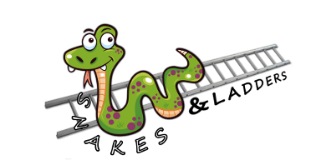

SNAKES AND LADDERS FITNESS
RULES
Play this game exactly how you would normally play snakes and ladders, but every time you roll the dice and move you must complete the activity in the square.
REMEMBER LADDERS TAKE YOU UP BUT SNAKES SLIDE YOU DOWN
Roll your dice (if you do not have a dice use an online dice - https://freeonlinedice.com/)
Move as many spaces forward as the number rolled e.g. roll a 3, move 3 spaces
Complete the exercise
Roll again and continue until you get to the finish square.

What happens when I reach the FINISH line?
Go back to start and repeat – you should play the game for 30-45 minutes

How do I know how many repetitions of the activity I should complete?
Each square has a specific colour and that colour tells you how many of each exercise you should do if the activity doesn’t have a time next to it!
Orange squares = 5 of each exercise
Pink squares = 10 of each exercise
Yellow squares = 15 of each exercise
Blue squares = 20 of each exercise

When your 30-45 mins of PE is complete, add up how many points you have scored and tweet me telling me how you got on! @Tennant_PE

Too hard or too easy? Next time change the number that each colour gives you to make it harder or easier!

