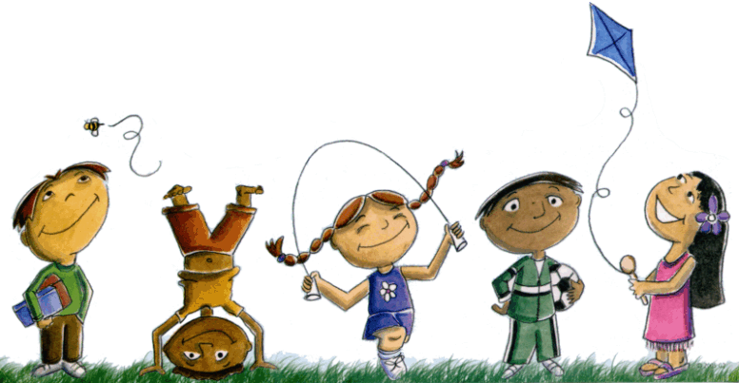
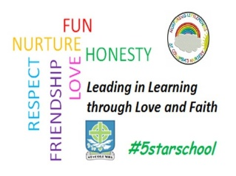
St. Columba’s Nursery Class
Home Learning: Health & Wellbeing Week beginning 27th April

Hand eye coordination and motor skills.  - Throw and catch a ball between 2 people. Start about 2 metres away, then try 3 metres.  - With a partner, bounce a ball between you. Start at 1 metre, then 2metres. Can you do 3 metres?  - Create your own ball games. | 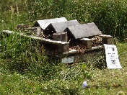 Bug Hotel  Go for a walk in your local green space. Have a look under stones and leaves, what might you find?  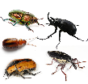  Gather some leaves, twigs and moss and make a bug hotel. Take some home and build one in your own garden or outdoor space and see if you get any visitors!  A stick can lead to a world of imagination and with each stone a new discovery. | Happy and Sad Faces Game.  Some children might be feeling a bit anxious at this time. This simple game helps your chid to share these feelings with you.  - Draw a happy face on a piece of paper and a sad face on another piece of paper.  - Start by explaining “different things can make us feel happy or sad”. “I feel happy when…” and hold up the appropriate face.  - Take turns and make the game fun. Your chid is learning to express and discuss their feelings.
Choose the route.  This activity gives your child the chance to choose what way to go while out for a walk.  Start by drawing arrows (left, right, forward, backward) on pieces of card.  When you come to a fork in the path, let your child choose a card to determine which way you go next. (modelling the use of directional language).  Along the way play a guessing game “what might we see in the next street?” | Make leaf/tree rubbings.  Collect leaves then place them underneath a piece of paper on a flat surface, rub over them with the side of a crayon to reveal the textures beneath. Do the same with a tree by holding the paper on the tree trunk and rub the crayon over the bark.  You could even try different surfaces around the house, just be careful with the crayons!

