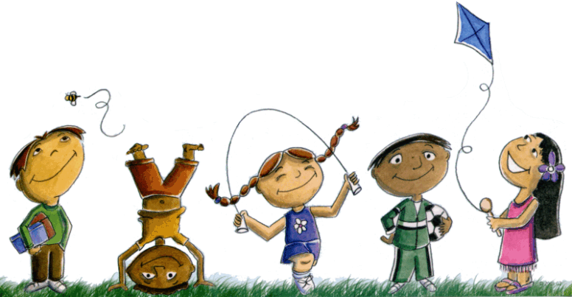
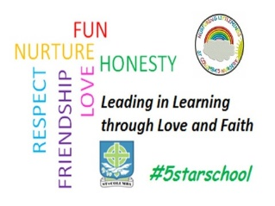
St. Columba’s Nursery Class
Home Learning: Digital learning Week beginning 27th April

Story Time in Space  Why not listen to a Story read by an Astronaut in Space. The Astronauts are carrying out experiments and you’ll see inside the Space Station.  https://storytimefromspace.com/books-2/books-approved-for-launch/ | Exercise at home  Daily PE Classes with Joe are fun and exciting for the whole family.  https://www.youtube.com/channel/UCAxW1XT0iEJo0TYlRfn6rYQ  We love Sticky Kids in Nursery, Join in with a musical workout at home  https://stickykids.podbean.com/ | Top Marks  A range of educational and fun games and  activities can be found in the Early Years Section.  https://www.topmarks.co.uk/Search.aspx?AgeGroup=1
Cbeebies  Why not try some games and activities from some of your favourite TV shows.  https://www.bbc.co.uk/cbeebies | Songs and Rhymes  Our favourite Nursery Rhymes all in one place. There is some fantastic activity ideas for you to try at home also.  https://supersimple.com/super-simple-songs/ | St Columba’s Nursery Twitter  Daily Challenges can be found on  our nursery twitter  https://twitter.com/ColumbaNursery?ref_src=twsrc%5Egoogle%7Ctwcamp%5Eserp%7Ctwgr%5Eauthor

