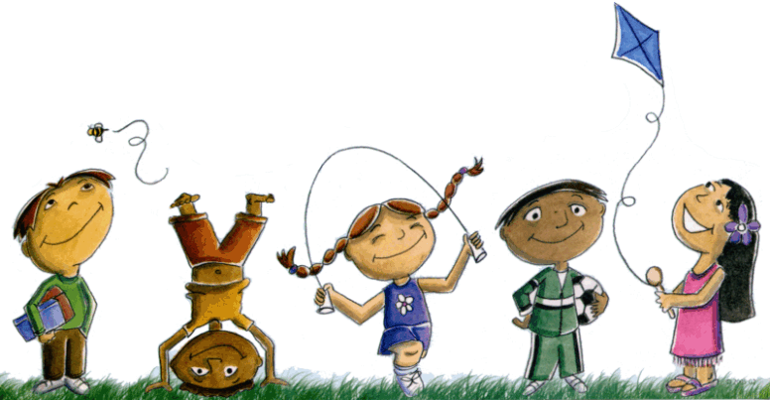
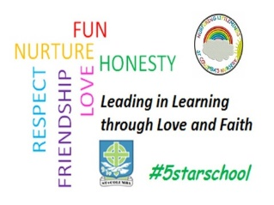
St. Columba’s Nursery Class
Home Learning: Numeracy

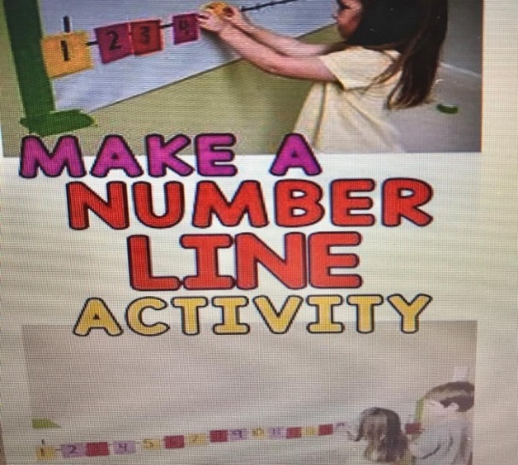  Write the numbers 0 -9 onto card.  Hang up a piece of string.  Get your child to peg the numbers in the correct order.  Challenge – adult peg up some of the numbers and child has to peg the missing numbers up in the correct order. | 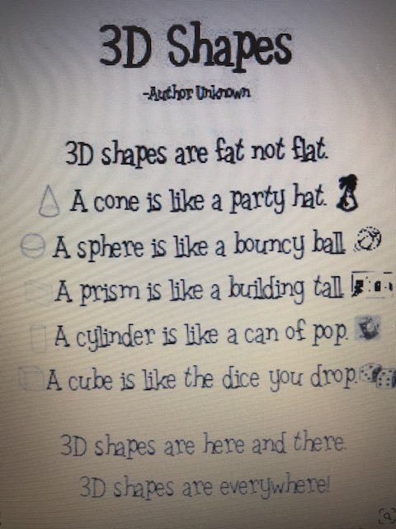  Can you find an object either in the house or outside for each of the shapes mentioned in the poem? | 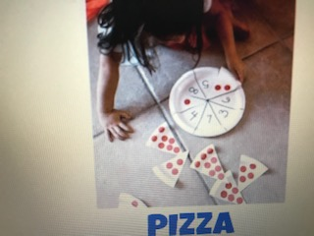  Pizza Slice Numbers  You need 2 paper plates. Don’t worry if you haven’t got any paper plates just draw two circles onto paper and cut out.  Draw triangles onto 1 plate like the diagram and number each section 1 – 8.  On the second shape draw triangles like the diagram and put coloured dots on each section from1 -8.  Can your child recognise how many dots there are on their ‘pizza’ slice and match it to the correct number on the pizza?
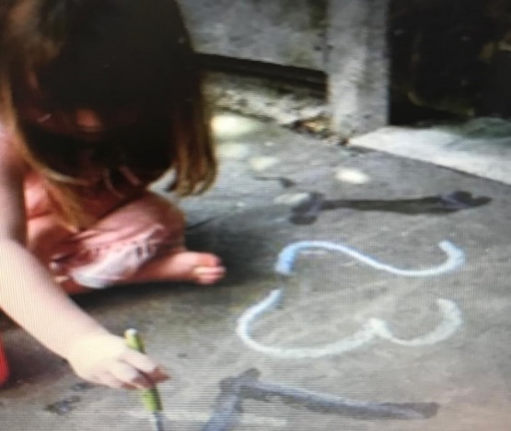  Use chalk to practise writing numbers outside. If you don’t have chalk you can use a paintbrush dipped in water. | 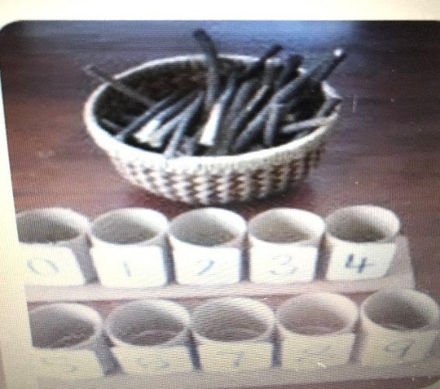  Use 9 plastic cups / tubs.  On the front of each tub write the numbers 0 -9.  Can your child put the correct number of objects into each tub? | 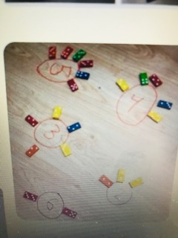  You need some dominoes for this activity.  Write numbers in paper circles.  Lie the circles on a flat surface.  Give your child the dominoes.  Child has to count total number of spots on each domino and lie next to the correct circle like in the diagram.

