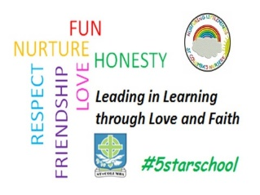St. Columba’s Primary School

Home Learning Grid – Developing The Young Workforce Early Level

|  |  |  |
| --- | --- | --- |
| When I am older I want to be….  What would be your dream career / job?  Why would you choose this career?  What skills do you think you would need for this career? | MILK BOTTLE BIRD FEEDER 🐦 🦅 This was a... - St Andrews Baby ... Be An Inventor  Using an empty milk cartoon can you make a bird feeder for your garden or to hang on a tree on your daily walk? | Architect  An architect designs buildings. Can you build a model? You can build a castle, a house, a shop – anything you like! You can use whatever you have – lego, cardboard boxes etc. |
| Fashion Designer  Create your own dressing up costume. Using clothes / shoes/ bags etc let your child have fun making their own costumes! | Developing The Young Work Force Thursday 23rd April should be ‘bring your child to work day’. Here is our special HOME EDITION to help your children learn about different careers and jobs. | Thank You Picture  Make a thank you picture to put in your window to say thank you to the NHS, post men and delivery drivers. |
| Be A Chef  Can you plan and prepare a meal with an adult? Remember to wash your hands first and be careful in the kitchen! | STEM Engineering Challenge  Make some paper aeroplanes. Which aeroplane can fly the furthest? Can you get your aeroplane to land in a basin? | Be A Scientist with an adult!  First put a little drop water in a dish. Add some black pepper. Put your finger in the water – what happens? Now add a tiny amount of liquid soap to your finger and put it back in the water – what happens now? |