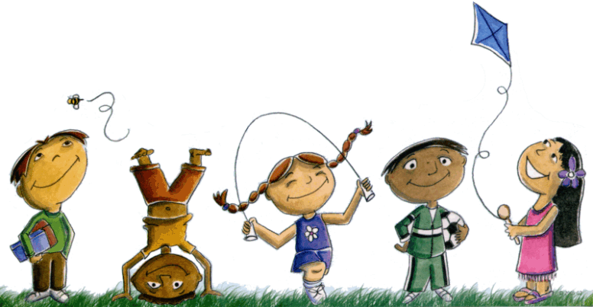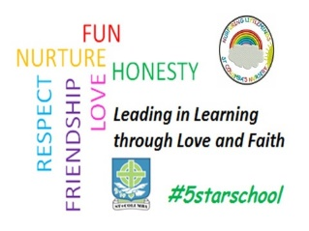St. Columba’s Nursery Class

Home Learning Activities Sheet

|  |  |  |  |  |
| --- | --- | --- | --- | --- |
| Monday | Tuesday | Wednesday | Thursday | Friday |
| **Pebble Painting**    When out on a walk for your daily exercise why not collect lots of flat stones.  These can be used to paint on.  You could make dominos or paint faces and make up stories. **Dance Party**   Put on some music and dance.  You can also play freeze.  Every time you stop the music you have to stand still. | **Rainbow Hunting**   Find an item that matches every colour of the rainbow. This can be played anywhere.  Coloured Wheel    Find objects around the house to make a coloured wheel.  Extension Task: You child could collect a variety of objects in different shades of each colour. | Hapa Zome  The Japanese art of hitting leaves with hammers to release their natural pigment onto cloth  Collect leaves and flowers when out for your daily exercise.  Lay them out on an old piece of cotton fabric.  Cover the material with a sheet of kitchen roll.  Hammer all over the kitchen roll for several minutes. You could use a big stone instead of a hammer.  Remove the kitchen roll and reveal your art work! | **Beans!!** There are different actions for each type of bean.  Each time the name of the bean is called out, the child(ren) should do the correct action.   * Runner Beans – run on the spot * String Beans – stretch up tall and be as thin as possible * Dwarf Beans – bend down and be as small as you can be * String Beans – stretch up tall | * Broad Beans – hold arms out wide and stand with wide legs * Chili Beans – shiver * Frozen Beans – everyone has to stand still * Jumping Beans – jump and down * Beans on Toast – lie on your back with arms across your chest!   Make A Snack  After all that activity get your child to help make a healthy snack. |