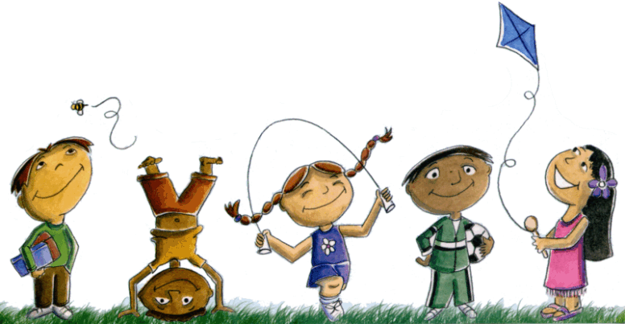
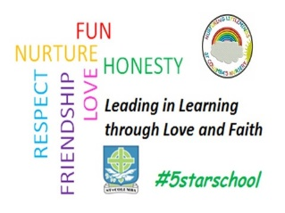
St. Columba’s Nursery Class
Home Learning Activities

Monday | Tuesday | Wednesday | Thursday | Friday
Grow A Bean  Grow a bean in a clear cup to watch the roots grow down and the stem grow up.  You need:  - A broad bean seed  - Jar  - Kitchen roll / napkin  - Water  Instructions  - Swirl a small amount of water around the jar. | Fold your napkin or kitchen roll and place into the jar. (Make the kitchen roll very slightly damp also)  - Place the bean seed in the jar resting on the napkin/ kitchen roll.  - Spray some water onto the bean every few days.  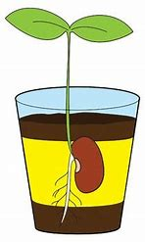  The bean should start to grow roots after a few days, this is called germination. | Indoor Treasure Hunt  Collect some of your child’s old toys that they haven’t played with for a while.  Hide them around the house.  Have a treasure hunt to find the toys.  You could make a treasure map to make this activity more exciting! | Board Games  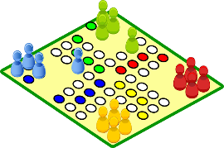  Have a games afternoon. Dig out those old board games and have fun playing together.  Dressing Up  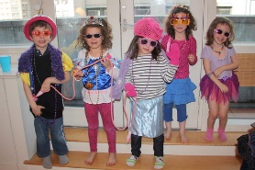  Using clothes / shoes/ bags etc let your child have fun making their own costumes! | Splish, Splash  Children love to play with water.  Fill up a basin and bucket and add in bath toys, or loose part items like sponges, wooden spoons etc.  Note: NEVER LEAVE CHILDREN ALONE WITH WATER! Ensure supervision as children can drown even in shallow water.

