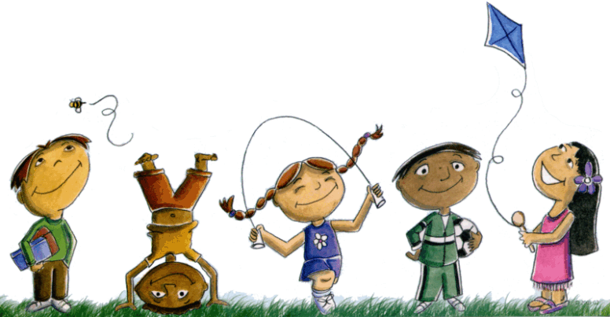
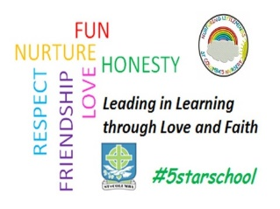
St. Columba’s Nursery Class
Home Learning Easter Holiday Activities Sheet 2

Monday | Tuesday | Wednesday | Thursday | Friday
Bottle Music  Materials:  - Plastic Bottles  - Glass Bottles  - Water  - Spoon  Instructions  Set out a variety of bottles, both glass and plastic. Help your child tap the sides of the bottles with spoons and encourage them to listen to the sound each one makes. | Next, show your children how to make music by blowing across the top of the bottles.  Then, put different amounts of water into each bottle to create different tones.  Explain how the water changes the sounds that the bottles make when they tap them with the spoon and when they blow over the top of them. | Hide The Toy  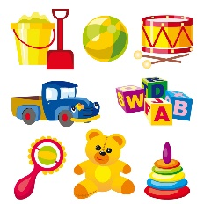  Use a toy that's not too big and place it somewhere visible but not too obvious and let the child look around the room to see if they can spot it.  Take turns about. As your child becomes confident, make it a little more difficult to find. | Music Making  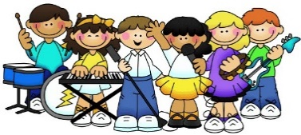  Children love music, especially when they get to make it.  Make your own instruments from items found around the home - yoghurt pots, pots and pans, rice, lentils etc.  Lead a marching band around the house. | Socks In A Box  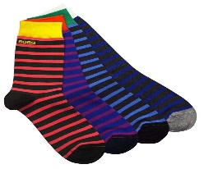  Throw balls of socks into a box or a bucket.  As your child gets better at getting the socks into the container move it further away to make it more difficult.  You could award points for each pair of socks that goes in!

