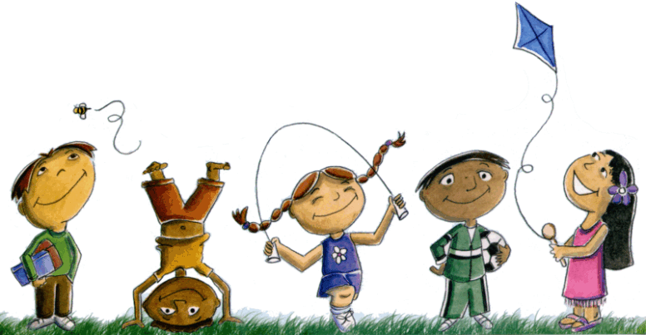
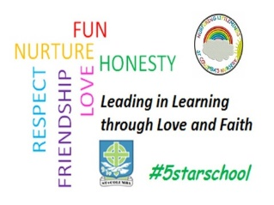
St. Columba’s Nursery Class
Home Learning Easter Holiday Activities Sheet 1

Monday | Tuesday | Wednesday | Thursday | Friday
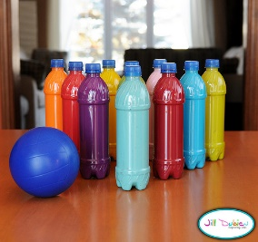  Bowling with plastic bottles.  Items needed: plastic bottles and a ball.  What to do:  Fill bottles with water.  Screw lid on tightly.  Mark out a bowling alley with tape/string.  You are ready to play. | Indoor Obstacle Course  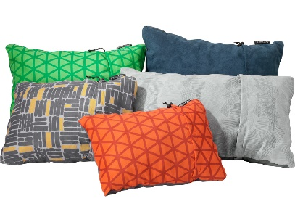  Make an indoor obstacle course.  You can use cushions, pillows, soft toys etc. Make a balance beam by marking a straight line on the floor with masking tape.  Use a sheet to crawl under.  Climb high, lie low, jog on the spot star jumps etc. Be creative! | Connect  Make a big connect the dots, connect the letters or connect the numbers. All this requires is large paper to spread on the floor and felt pens. (You could use an old roll of wall paper) | Bubble Painting  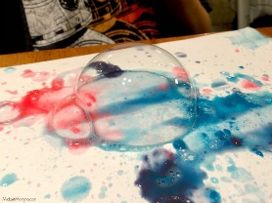  Items required: a bowl to put the paint in, some washing up liquid, a straw and pieces of paper.  Instructions:  Mix together the paint and some washing up liquid in the bowl. Add some water until it is runny enough to blow bubbles. Use the drinking straw to blow into the paint to make bubbles. Gently place the paper on top of the bubbles. | 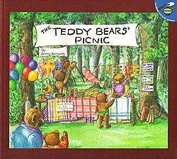  Teddy Bear’s Picnic  Have a Teddy Bear’s Picnic. Children can prepare food and set out a blanket on the carpet or outdoors if you wish.  After your picnic you could play  Balloon Tennis  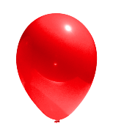  Use your hands to play balloon tennis!

