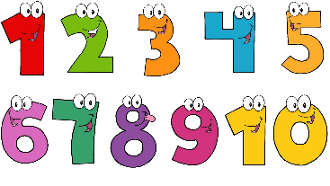
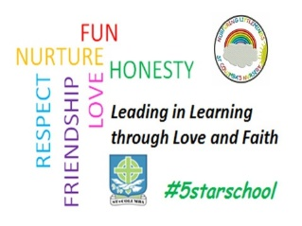
St. Columba’s Nursery Class
Home Learning Maths Activities Week 2

Shapes  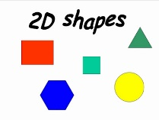  I can recognise and describe flat (2d) shapes  - Ask your child to find 2d shapes around the home, for example, circle, triangle, square and rectangle.  - Compare the properties of different shapes, for example, a triangle has three sides. | Shapes  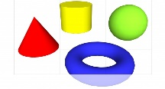  I can recognise and sort 3d shapes.  - Ask your child to find 3d objects around the home, for example a tin and a cereal box  - Get your child to sort the objects according to various criteria, for example straight edges, round, flat and curved | Shapes  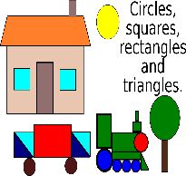  I can use 2d and 3d shapes to make a picture  - Get your child to make a shape picture using different shapes.  - Link to Shape Pattern game on top marks  https://www.topmarks.co.uk/ordering-and-sequencing/shape-patterns
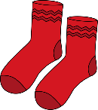  Matching and Sorting  I can match objects by colour and pattern.  - Get your child to match objects that belong together like socks, shoes and gloves. | 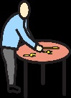  Matching and Sorting  I can match and sort objects by shape and size.  - Mealtimes can encourage sorting and matching by setting the table, sorting the cutlery, matching cups, saucers and plates. | Matching and Sorting  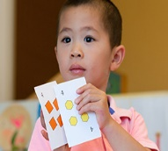  I can play a matching and sorting game.  - Play a game of snap or matching pairs with your child.  - Dominoes is another good game for matching and developing counting skills.

