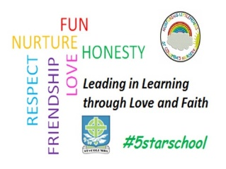
St. Columba’s Nursery Class
Home Learning Literacy Activities Week 2

I can play with a puppet  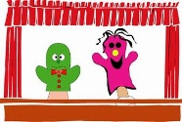  Playing with puppets encourages children to engage in pretend play with others.  Make a puppet  - Puppets can be made from all sorts of materials, socks, spoons, sticks or finger puppets.  - Hold simple conversations between your puppet and your child’s e.g.; What is your name? What is your favourite colour? Share a story together using your puppet or sing a song. | I can listen  Guess what happens next  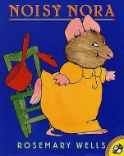  - Let your child choose a story book for you to read.  - Discuss the book while you’re reading it.  - Ask your child questions, for example ‘what do you think is going to happen next?’, or ‘how do you think she is feeling now? | I can listen  Guess the rhyme  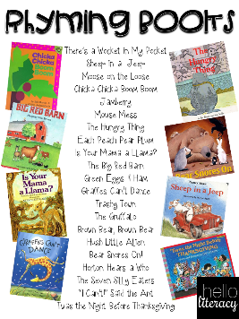  Read rhyming books and get the children to call out the words at the end of sentences.
Mark Making  - Make play dough  - https://www.bbcgoodfood.com/howto/guide/playdough-recipe  Rolling and kneading the dough is great to develop strength in finger muscles needed for holding and controlling writing implements. | Mark Making  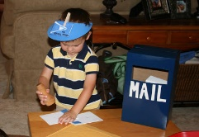  - Make your own post office / shop/ dentist etc.  - Add old envelopes and some paper for your child to write on. | Mark Making  Letter formation  This site allows children to trace over letter shapes.  https://www.doorwayonline.org.uk/activities/letterformation/

